**Module 3 Activity 1: Database Access**

Saurabh Kale

IFT 458/554: Middleware Programming & Database Security

Dinesh Sthapit

Sep 17th, 2023

**Module 3 Activity 1: Database Access**

**Select Statement for Proof of Installation-**

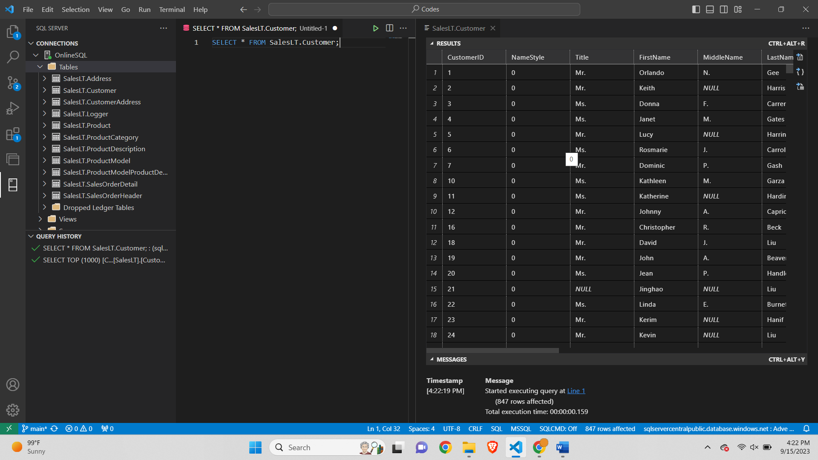

**SQL SELECT Statement to Query Data in four Tables-**

**Select Statement for TOP 20 Users-**

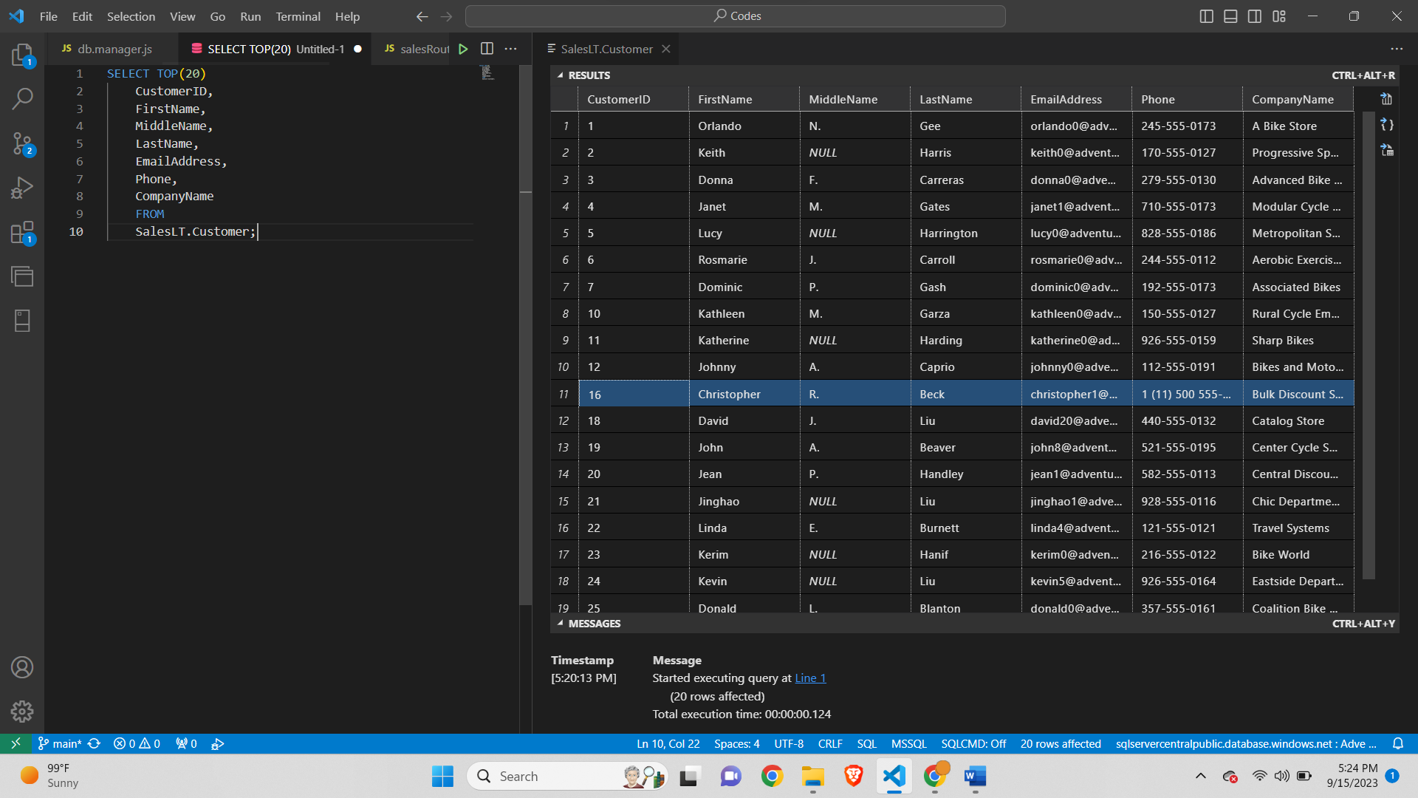

**Select Statement for TOP 20 Products (Sales)-**

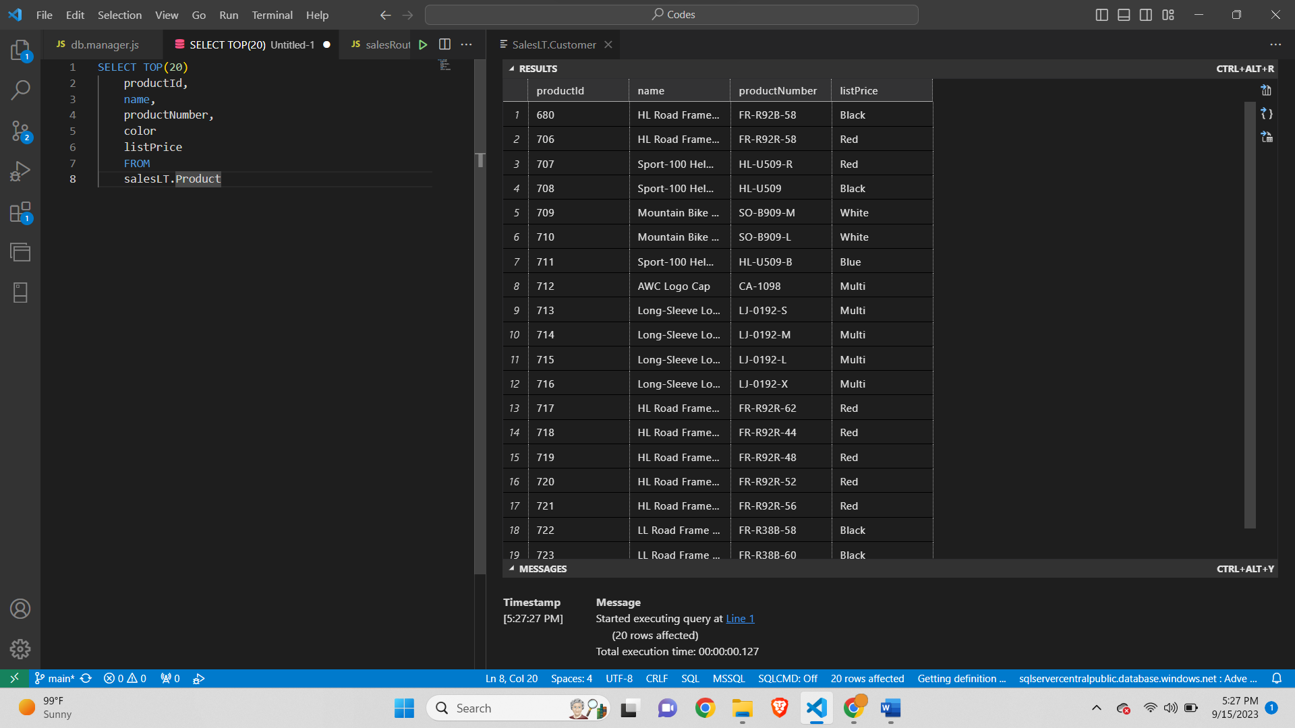

**Select Statement for TOP 20 Address-**

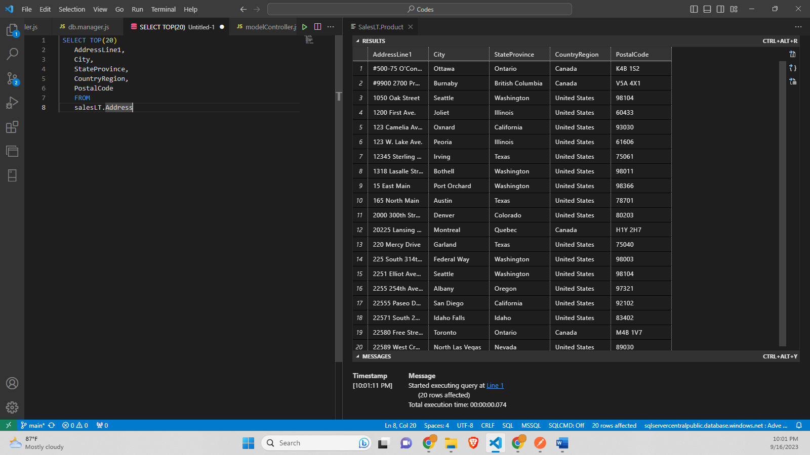

**Select Statement for TOP 20 Model-**

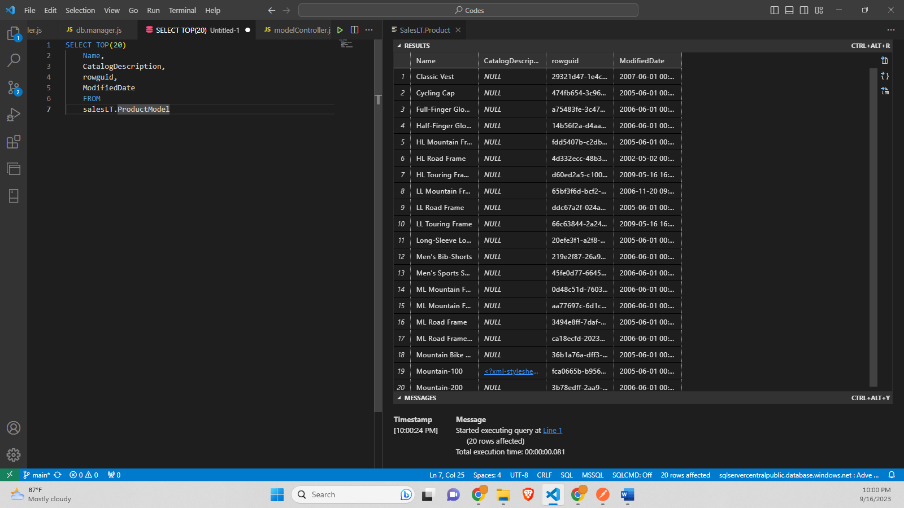

**Select Statement for Joining of 3 Tables-**

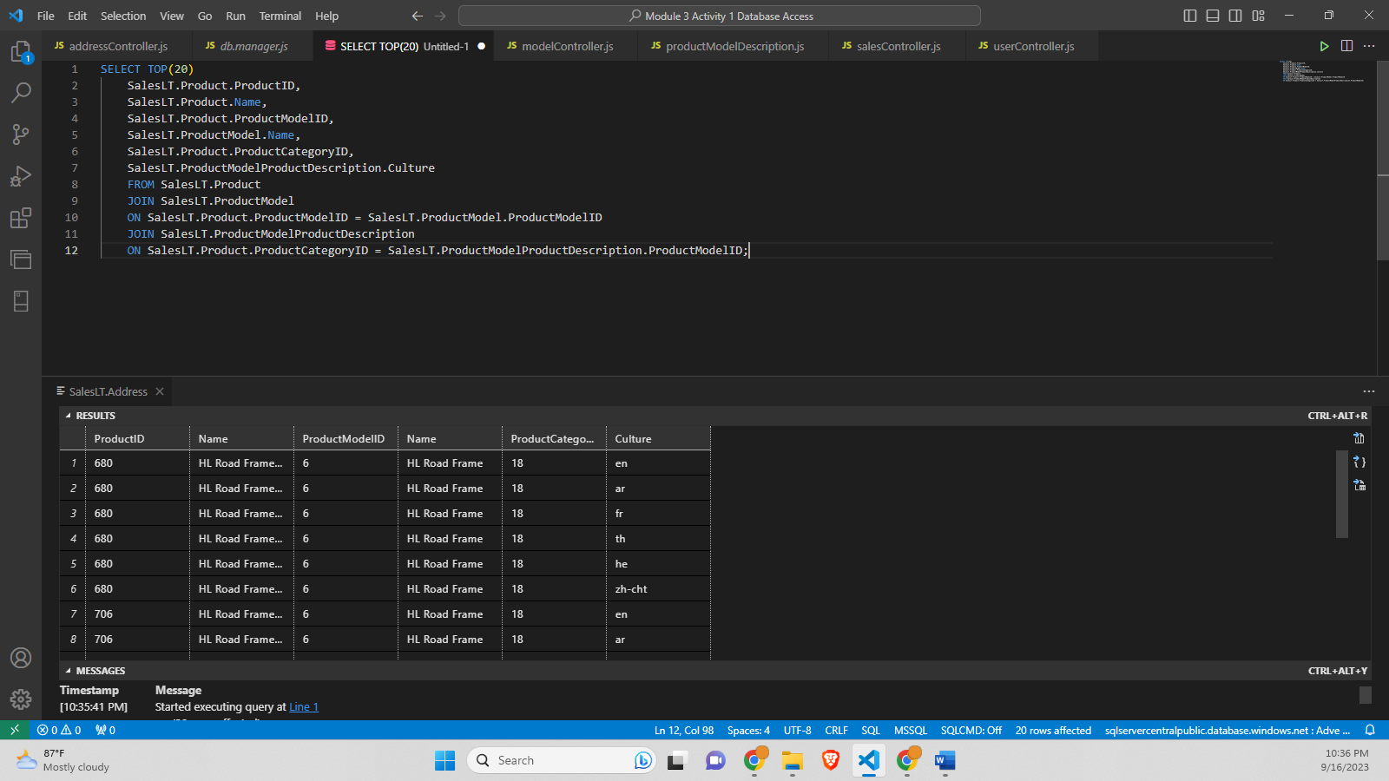

**App.js-**

// Name: Saurabh Kale

// ASUID: 1223450319

// Date: 9/17/2023

const express = require('express');

const morgan = require('morgan');

const cors = require("cors");

const app = express();

const path = require('path')

//This is CORS Ref:https://developer.mozilla.org/en-US/docs/Web/HTTP/CORS

app.use(express.urlencoded({extended: true}));

// if(process.env.NODE_ENV === 'development'){

    app.use(morgan('dev'));

// }

app.set('view engine', 'ejs');

console.log('dirname', __dirname);

app.set('views',path.join(__dirname, 'views'));

var corsOptions = {

    origin: "http://localhost:8080"

};

app.use(cors(corsOptions));

// 1) MIDDLEWARES Morgan is used for debugging

if (process.env.NODE_ENV === 'development') {

app.use(morgan('dev'));

}

// 2)MIDDLEWARE json is used for injecting the body attribute in the pipeline

app.use(express.json());

// parse requests of content-type - application/x-www-form-urlencoded

app.use(express.urlencoded({ extended: true }));

app.use((req, res, next) => {

console.log('Hello from the middleware 👋');

next();

});

// Root Route

app.get('/',(req,res) =>{

    console.log(req.requestTime);

    console.log('ROOT was reached!');

    // res.send('You have reached the ROOT!');

    res.render('index', {title: 'Home'});

});

// 3) MIDDLE ROUTES loading

const salesRouter = require('./routes/salesRoutes');

app.use('/api/v1/sales', salesRouter);

const userRouter = require('./routes/userRoutes');

app.use('/api/v1/users', userRouter);

const addressRouter = require('./routes/addressRoutes');

app.use('/api/v1/address', addressRouter);

const modelRouter = require('./routes/modelRoutes');

app.use('/api/v1/models', modelRouter);

const productModelDescription = require('./routes/productModelDescription');

app.use('/api/v1/productModelDescription', productModelDescription);

module.exports = app;

**App.js Screenshot-**

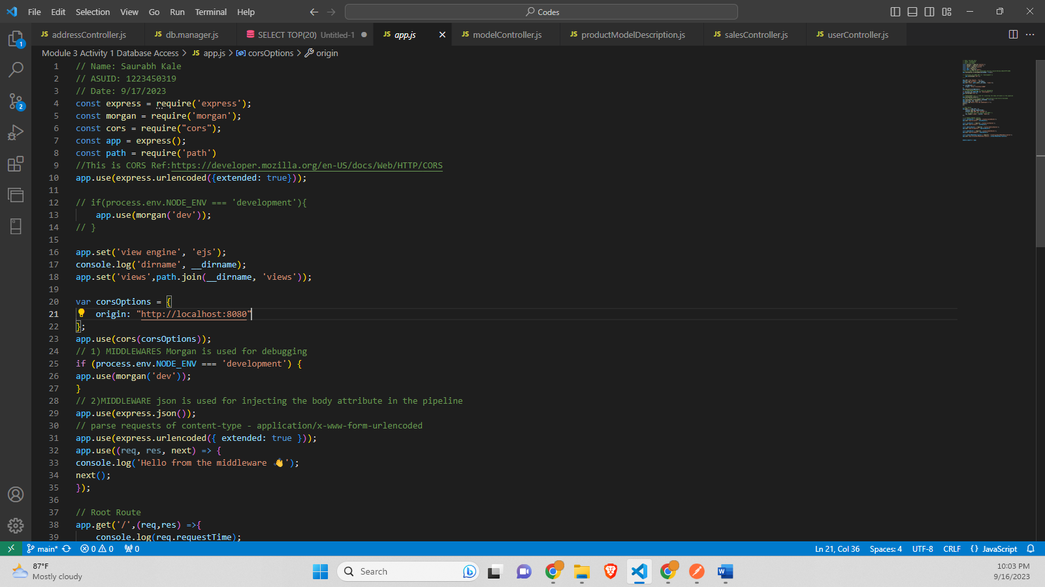

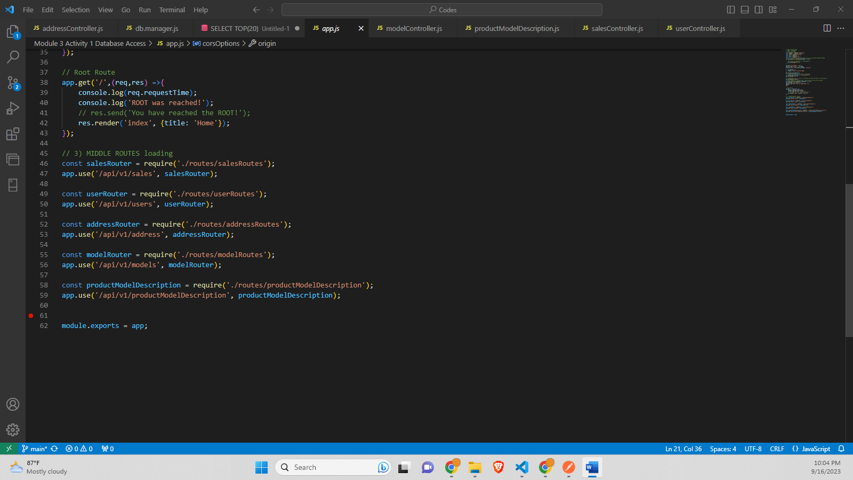

**Server.js code-**

const dotenv = require('dotenv');

dotenv.config({ path: './config.env' }); // this line has to come first since we need to tell where is the config file.

const app = require('./app');

const port = process.env.PORT || 3000;

app.listen(port, () => {

console.log(`App running on port ${port}...`);

});

**Server.js Screenshot-**

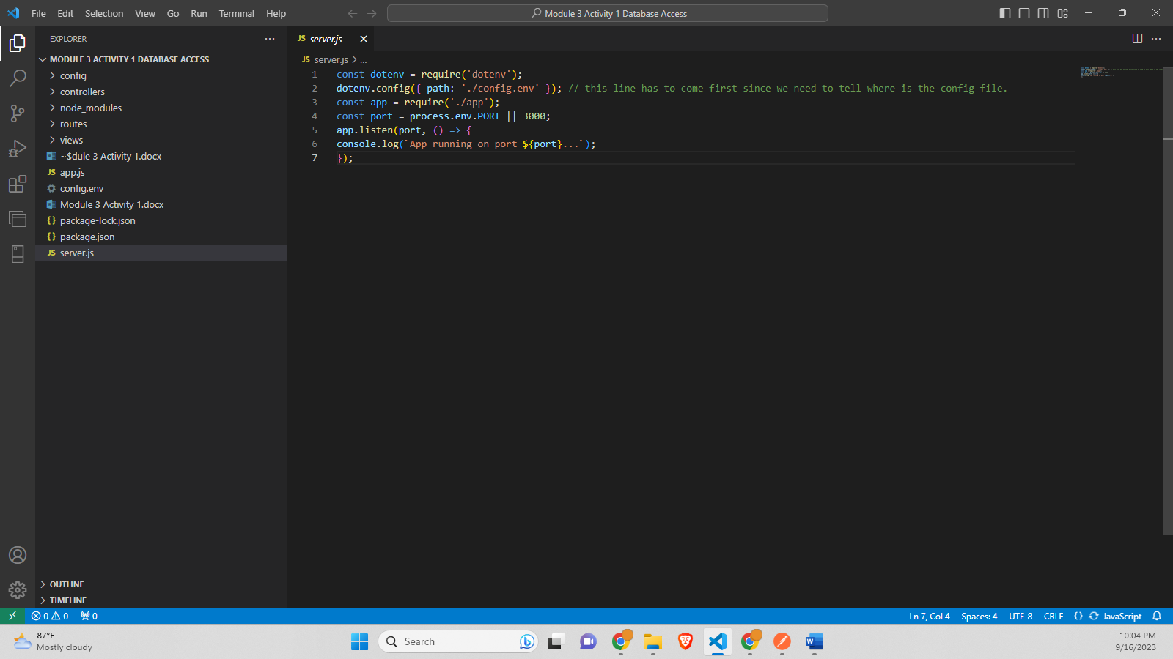

**config.env-**

NODE_ENV=development

PORT=8000

DBUSERNAME=sqlfamily

PASSWORD=sqlf@m1ly

DATABASE=AdventureWorks

**config.env Screenshot-**

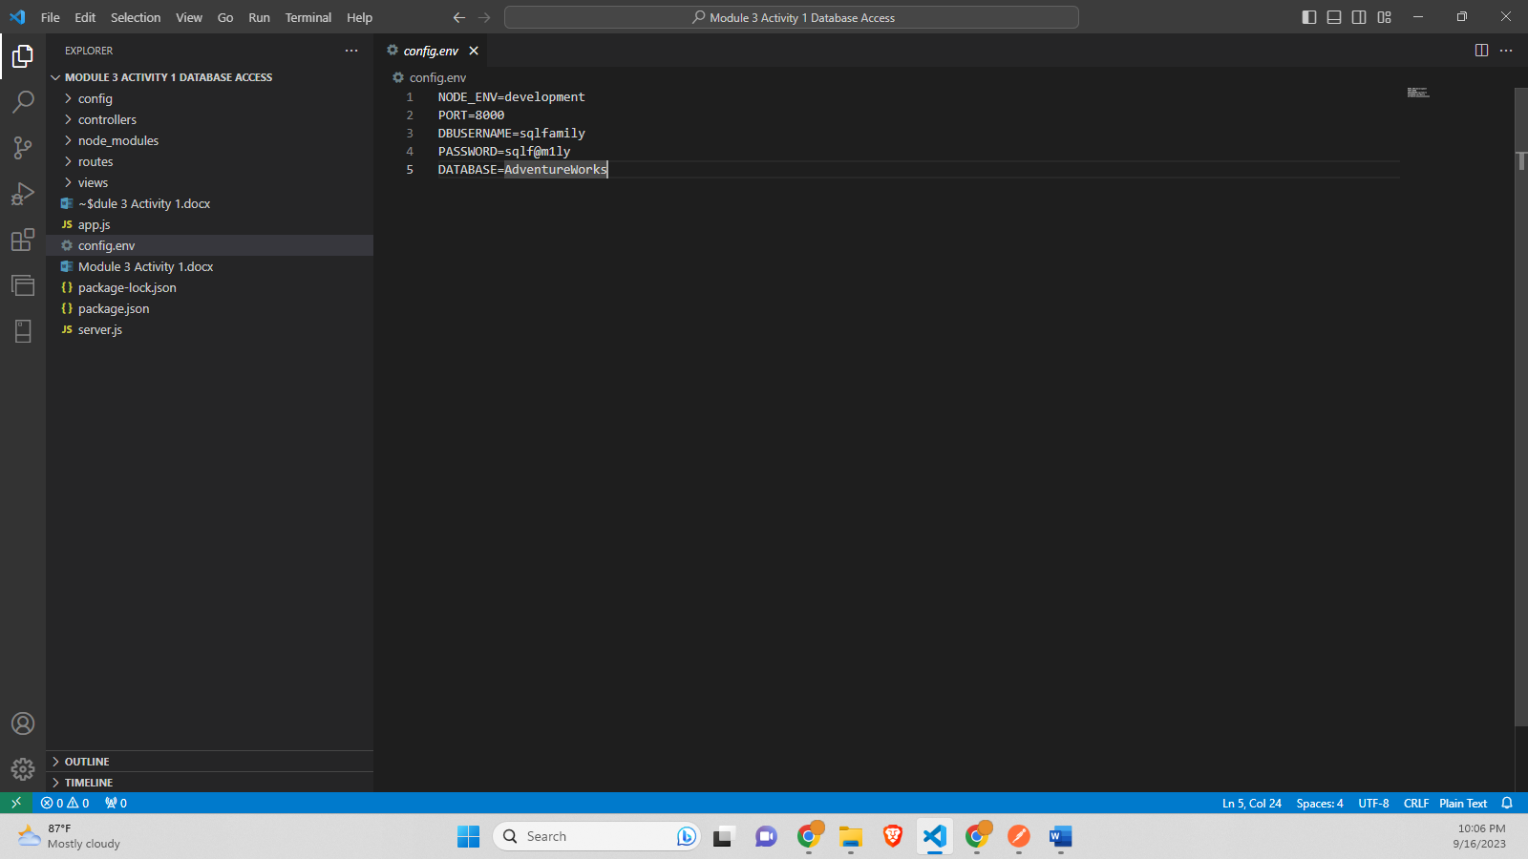

**db.config.js-**

const sqlConfig = {

    server: "sqlservercentralpublic.database.windows.net",

    user: process.env.DBUSERNAME,

    password: process.env.PASSWORD,

    database: process.env.DATABASE,

    pool: {

    idleTimeoutMillis: 60000

    },

    options:{

    encrypted: true, // for azure

    trustServerCertificate: false,

    useUTC: true

    }

    }

    module.exports = sqlConfig;

**Screenshot-**

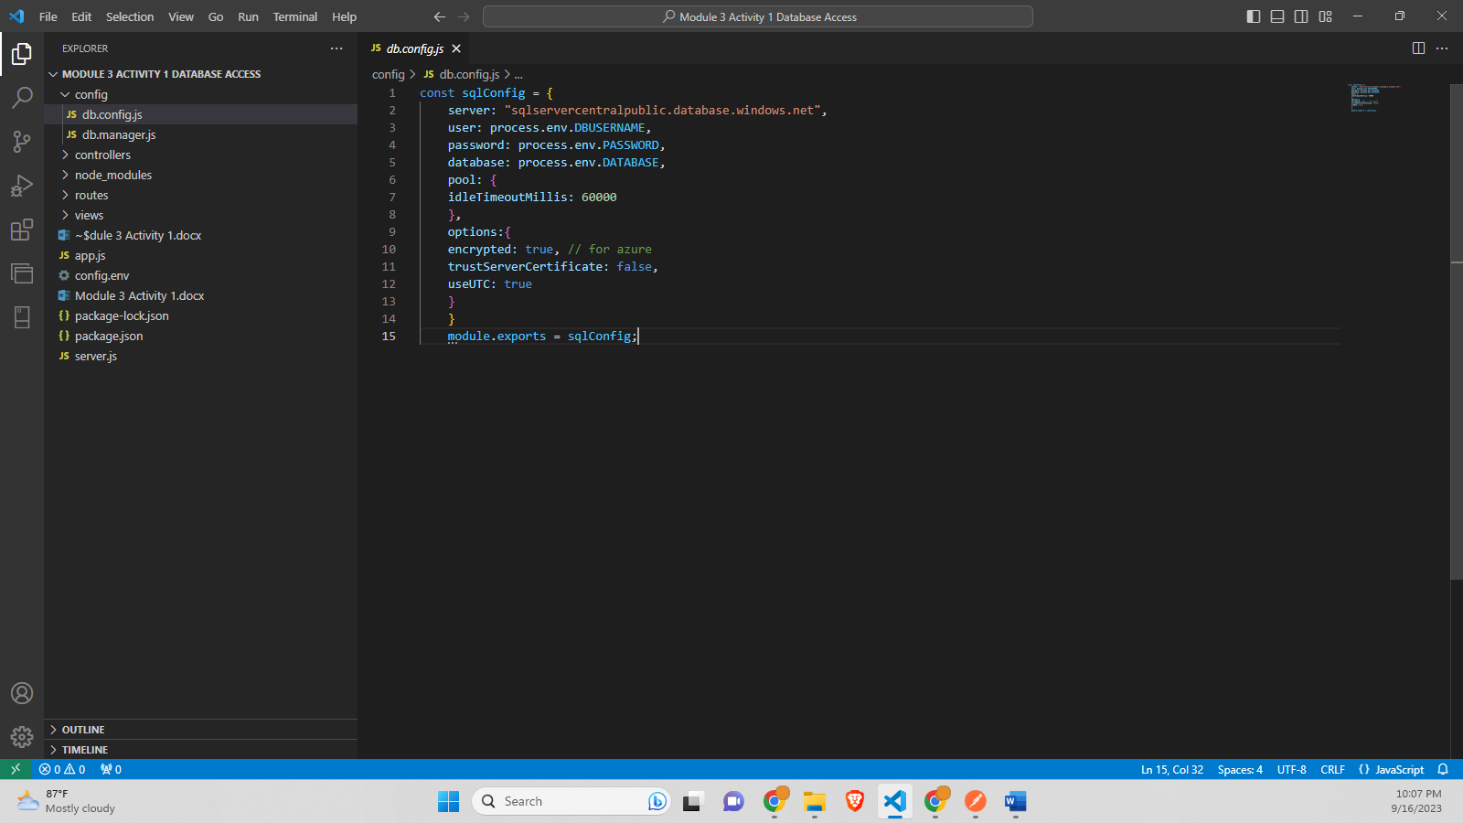

**db.manager.js-**

// Name: Saurabh Kale

// ASUID: 1223450319

// Date: 9/17/2023

const sql = require('mssql');

const dbConnection = require('./db.config');

console.log(dbConnection);

async function getSalesProducts(){

    console.log(' Connecting to SQL....... Cloud Server');

    let dbContext = await sql.connect(dbConnection);

    console.log('The Databse connection was Successful');

    console.log('Getting data');

    let results = await dbContext.request()

    .query(`

    SELECT TOP(20)

    productId,

    name,

    productNumber,

    color

    listPrice

    FROM

    salesLT.Product

    `);

    console.log(`Returned SQL results`);

    return results;

}

async function getUser(){

    console.log(' Connecting to SQL....... Cloud Server');

    let dbContext = await sql.connect(dbConnection);

    console.log('The Databse connection was Successful');

    console.log('Getting data');

    let results = await dbContext.request()

    .query(`

    SELECT TOP(20)

    CustomerID,

    FirstName,

    MiddleName,

    LastName,

    EmailAddress,

    Phone,

    CompanyName

    FROM

    SalesLT.Customer;

    `);

    console.log(`Returned SQL results`);

    return results;

}

async function getProductModel(){

    console.log(' Connecting to SQL....... Cloud Server');

    let dbContext = await sql.connect(dbConnection);

    console.log('The Databse connection was Successful');

    console.log('Getting data');

    let results = await dbContext.request()

    .query(`SELECT TOP(20)

    Name,

    CatalogDescription,

    rowguid,

    ModifiedDate

    FROM

    salesLT.ProductModel`);

    console.log(`Returned SQL results`);

    return results;

}

async function getAddress(){

    console.log(' Connecting to SQL....... Cloud Server');

    let dbContext = await sql.connect(dbConnection);

    console.log('The Databse connection was Successful');

    console.log('Getting data');

    let results = await dbContext.request()

    .query(`  SELECT TOP(20)

    AddressLine1,

    City,

    StateProvince,

    CountryRegion,

    PostalCode

    FROM

    salesLT.Address`

    );

    console.log(`Returned SQL results`);

    return results;

}

async function getProductModelAndDescription(){

    console.log(' Connecting to SQL....... Cloud Server');

    let dbContext = await sql.connect(dbConnection);

    console.log('The Databse connection was Successful');

    console.log('Getting data');

    let results = await dbContext.request()

    .query(`SELECT TOP(20)

    SalesLT.Product.ProductID,

    SalesLT.Product.Name,

    SalesLT.Product.ProductModelID,

    SalesLT.ProductModel.Name,

    SalesLT.Product.ProductCategoryID,

    SalesLT.ProductModelProductDescription.Culture

    FROM SalesLT.Product

    JOIN SalesLT.ProductModel

    ON SalesLT.Product.ProductModelID = SalesLT.ProductModel.ProductModelID

    JOIN SalesLT.ProductModelProductDescription

    ON SalesLT.Product.ProductCategoryID = SalesLT.ProductModelProductDescription.ProductModelID;`

    );

    console.log(`Returned SQL results`);

    return results;

}

//Export

module.exports = {getSalesProducts :getSalesProducts, getUser:getUser, getProductModel:getProductModel, getAddress: getAddress, getProductModelAndDescription: getProductModelAndDescription};

**Screenshot-**

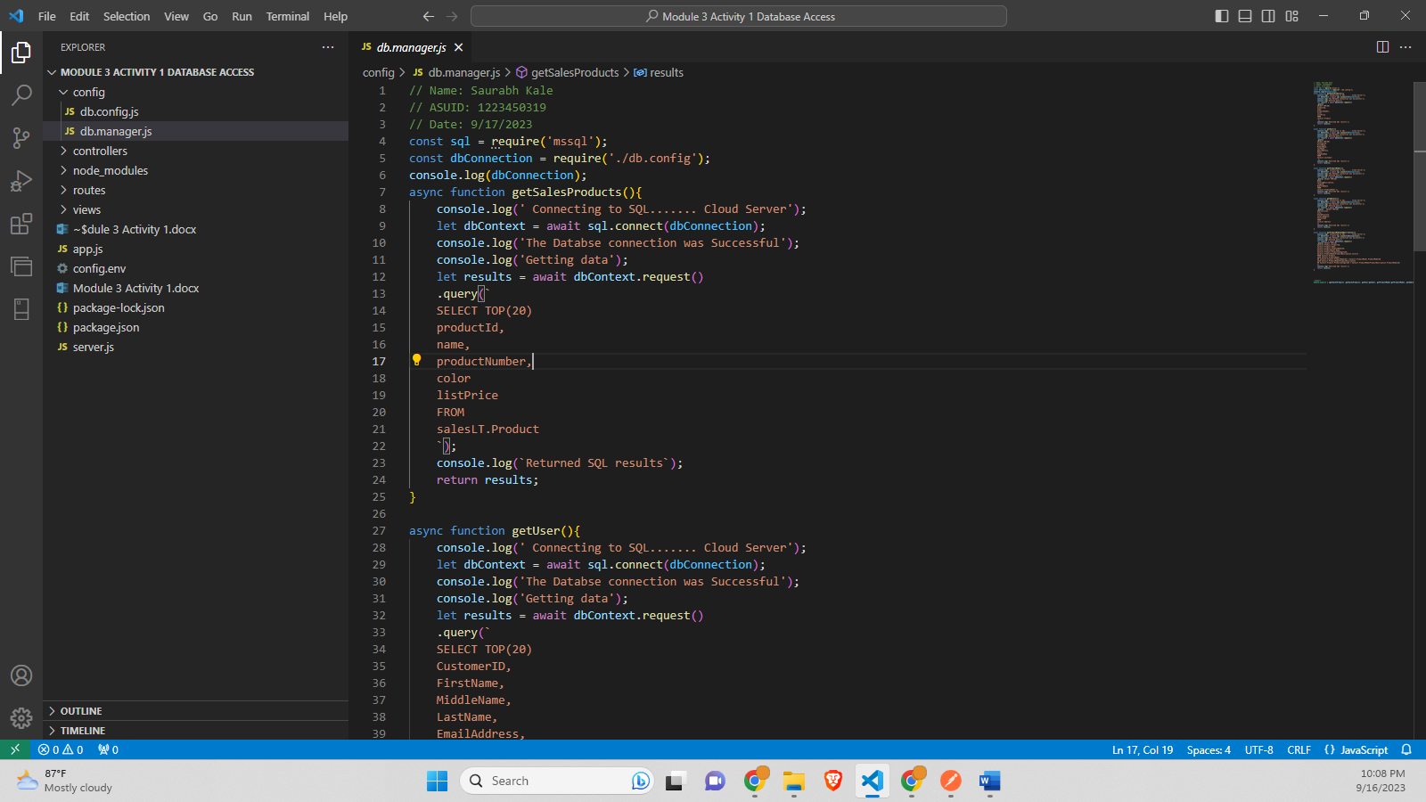

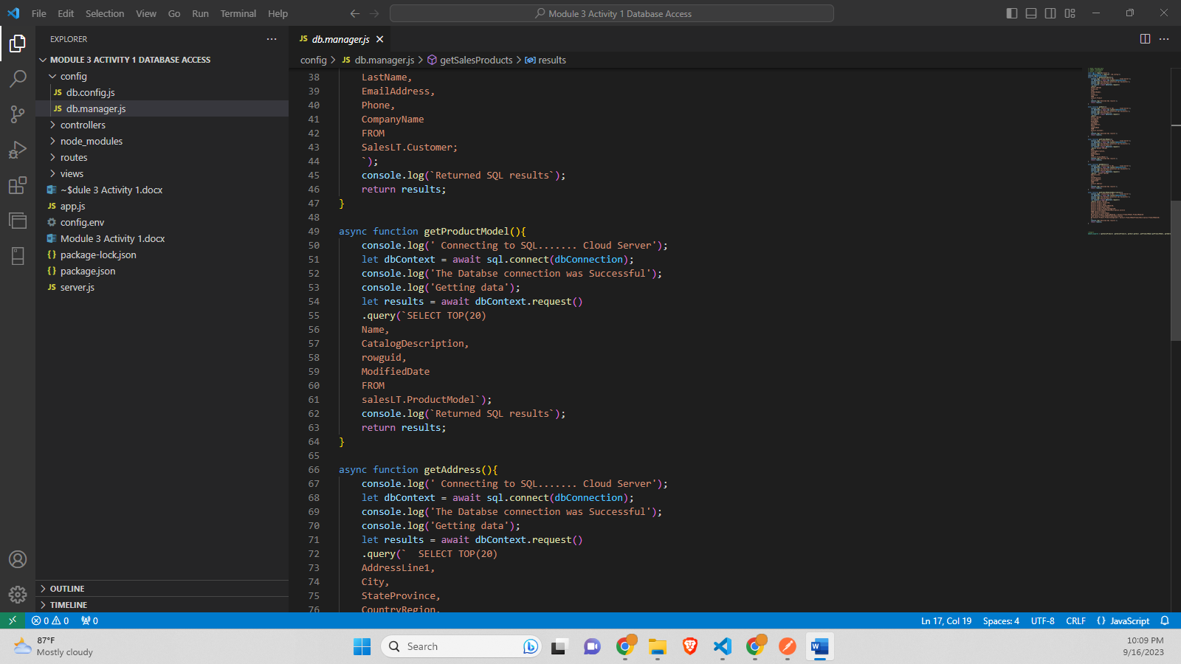

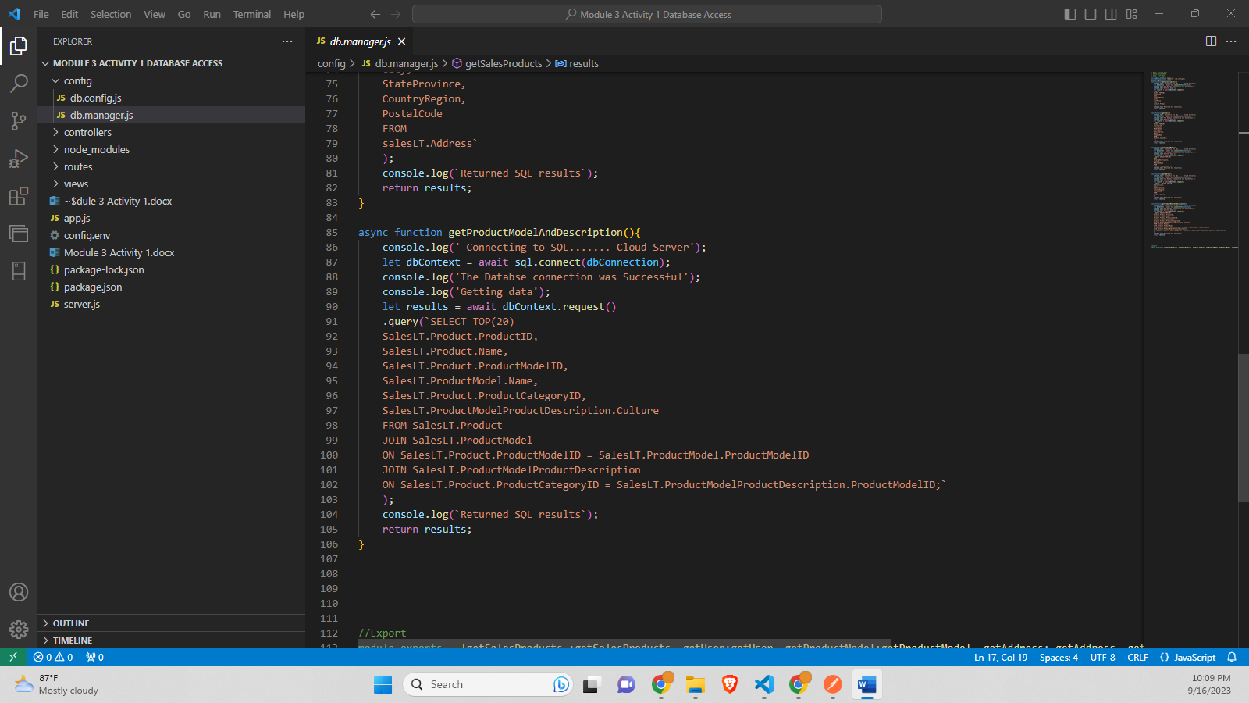

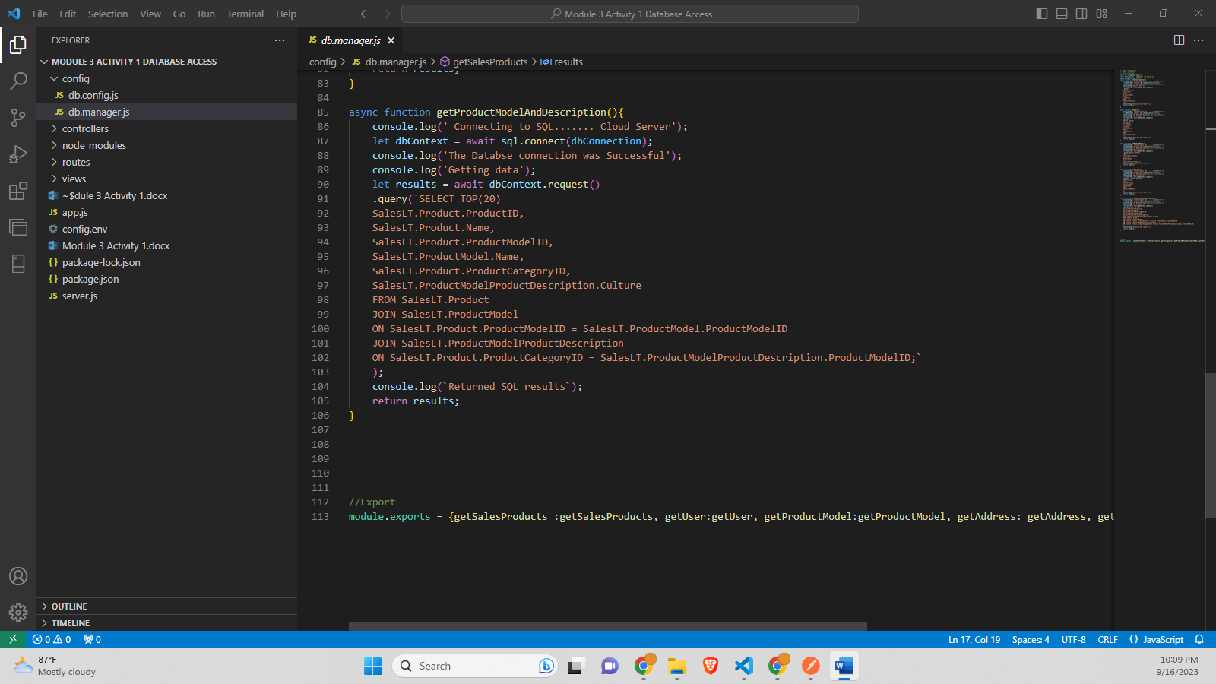

**addressController.js-**

// Name: Saurabh Kale

// ASUID: 1223450319

// Date: 9/17/2023

const db = require('../config/db.manager');

exports.getAllAddresses = function (req, res) {

const addressProduct = db.getAddress().then(results=>{

console.log(results);

res.status(200).json({

status: 'successfull',

data: results.recordsets[0]

}); // send all the data

// res.render('addressView', { data: results.recordsets[0]});

});

}

exports.getAddressByID = function( req, res){

const {id} = req.params; // get id

res.status(200).json({

status: 'no implemented'

});

}

exports.createNewAddress = function( req, res){ // must select the body to be raw->JSON in Postman

const {body} = req;// req.body (attribute)

const {id} = req.params;// get (attribute)

res.status(200).json({

status: 'no implemented'

});

}

exports.patchAddressById = function( req, res){ // must select the body to be raw->JSON in Postman

const {body} = req;// req.body (attribute)

const {id} = req.params;// get id (attribute)

res.status(200).json({

status: 'no implemented'

});

}

exports.deleteAddressByID = function( req, res){ // must select the body to be raw->JSON in Postman

const {body} = req;// req.body (attribute)

const {id} = req.params;// get id

res.status(200).json({

status: 'no implemented'

});

}

**Screenshot-**

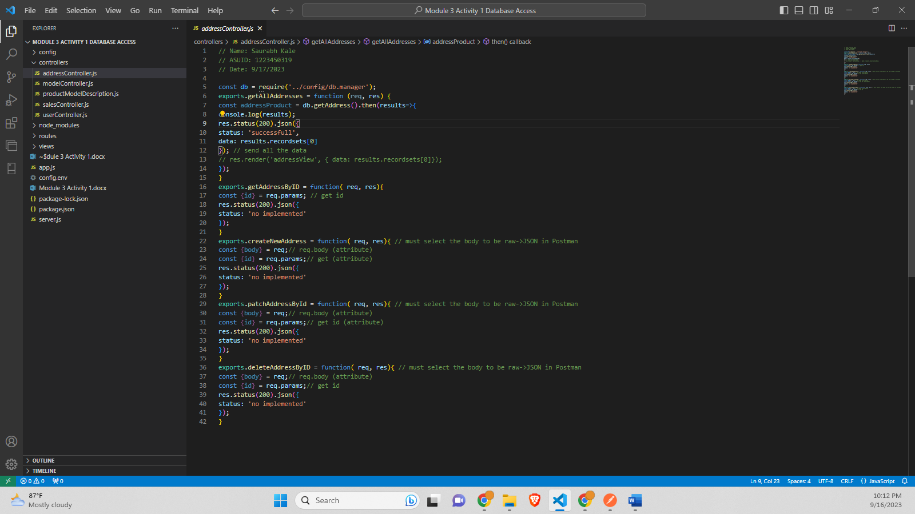

**modelController.js-**

// Name: Saurabh Kale

// ASUID: 1223450319

// Date: 9/17/2023

const db = require('../config/db.manager');

exports.getAllModels = function (req, res) {

const model = db.getProductModel().then(results=>{

console.log(results);

res.status(200).json({

status: 'successfull',

data: results.recordsets[0]

}); // send all the data

// res.render('modelsView', { data: results.recordsets[0]});

});

}

exports.getModelByID = function( req, res){

const {id} = req.params; // get id

res.status(200).json({

status: 'no implemented'

});

}

exports.createNewModel = function( req, res){ // must select the body to be raw->JSON in Postman

const {body} = req;// req.body (attribute)

const {id} = req.params;// get (attribute)

res.status(200).json({

status: 'no implemented'

});

}

exports.patchModelById = function( req, res){ // must select the body to be raw->JSON in Postman

const {body} = req;// req.body (attribute)

const {id} = req.params;// get id (attribute)

res.status(200).json({

status: 'no implemented'

});

}

exports.deleteModelByID = function( req, res){ // must select the body to be raw->JSON in Postman

const {body} = req;// req.body (attribute)

const {id} = req.params;// get id

res.status(200).json({

status: 'no implemented'

});

}

**Screenshot-**

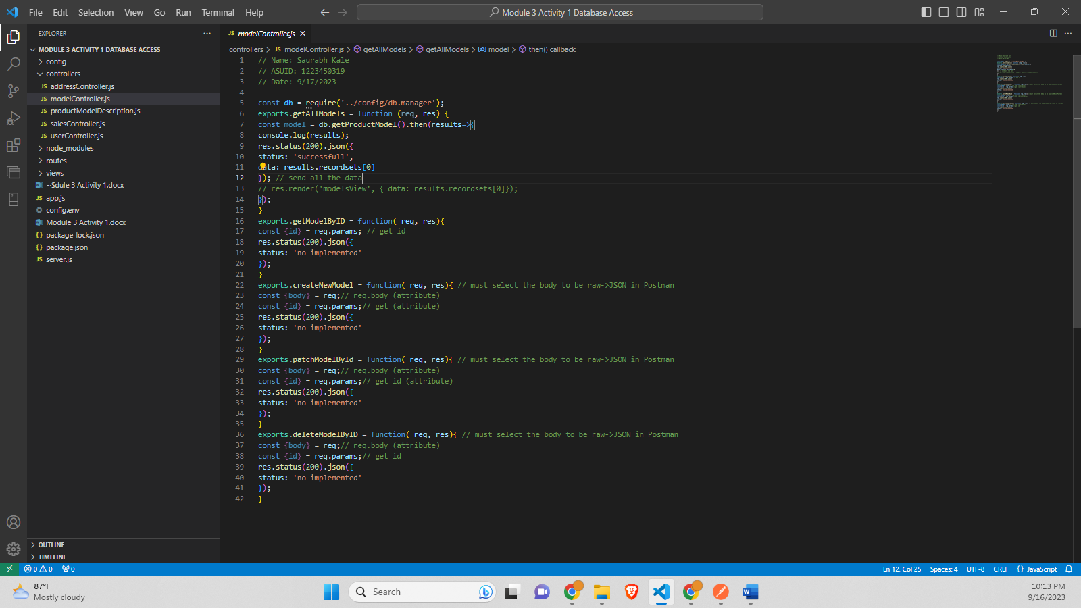

**productModelDescription.js-**

// Name: Saurabh Kale

// ASUID: 1223450319

// Date: 9/17/2023

const db = require('../config/db.manager');

exports.getAllProductModelAndDescription = function (req, res) {

const getProductModelAndDescription = db.getProductModelAndDescription().then(results=>{

console.log(results);

res.status(200).json({

status: 'successfull',

data: results.recordsets[0]

}); // send all the data

// res.render('productModelDescriptionView', { data: results.recordsets[0]});

});

}

exports.getProductModelAndDescriptionByID = function( req, res){

const {id} = req.params; // get id

res.status(200).json({

status: 'no implemented'

});

}

exports.createNewProductModelAndDescription = function( req, res){ // must select the body to be raw->JSON in Postman

const {body} = req;// req.body (attribute)

const {id} = req.params;// get (attribute)

res.status(200).json({

status: 'no implemented'

});

}

exports.patchProductModelAndDescriptionById = function( req, res){ // must select the body to be raw->JSON in Postman

const {body} = req;// req.body (attribute)

const {id} = req.params;// get id (attribute)

res.status(200).json({

status: 'no implemented'

});

}

exports.deleteProductModelAndDescriptionByID = function( req, res){ // must select the body to be raw->JSON in Postman

const {body} = req;// req.body (attribute)

const {id} = req.params;// get id

res.status(200).json({

status: 'no implemented'

});

}

**Screenshot-**

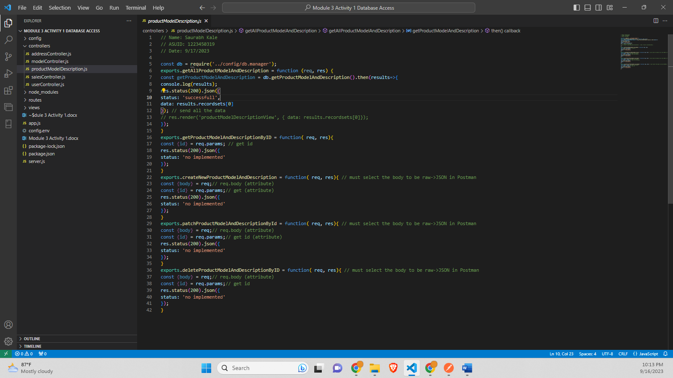

**salesController.js-**

// Name: Saurabh Kale

// ASUID: 1223450319

// Date: 9/17/2023

const db = require('../config/db.manager');

exports.getAllSales = function (req, res) {

const salesProduct = db.getSalesProducts().then(results=>{

console.log(results);

res.status(200).json({

status: 'successfull',

data: results.recordsets[0]

}); // send all the data

// res.render('salesView', { data: results.recordsets[0]});

});

}

exports.getSalesByID = function( req, res){

const {id} = req.params; // get id

res.status(200).json({

status: 'no implemented'

});

}

exports.createNewSales = function( req, res){ // must select the body to be raw->JSON in Postman

const {body} = req;// req.body (attribute)

const {id} = req.params;// get (attribute)

res.status(200).json({

status: 'no implemented'

});

}

exports.patchSalesById = function( req, res){ // must select the body to be raw->JSON in Postman

const {body} = req;// req.body (attribute)

const {id} = req.params;// get id (attribute)

res.status(200).json({

status: 'no implemented'

});

}

exports.deleteSalesByID = function( req, res){ // must select the body to be raw->JSON in Postman

const {body} = req;// req.body (attribute)

const {id} = req.params;// get id

res.status(200).json({

status: 'no implemented'

});

}

**Screenshot-**

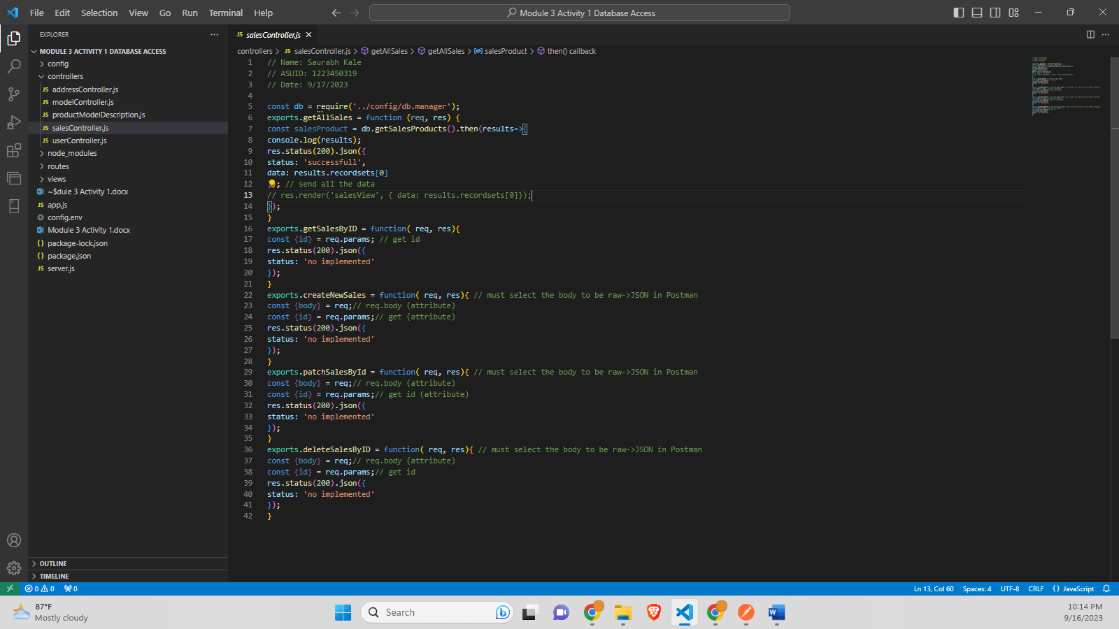

**userController.js-**

// Name: Saurabh Kale

// ASUID: 1223450319

// Date: 9/17/2023

const db = require('../config/db.manager');

exports.getAllUser = function (req, res) {

const user = db.getUser().then(results=>{

    console.log(results);

    res.status(200).json({

        status: 'successfull',

        data: results.recordsets[0]

        }); // send all the data

    // res.render('userView', { data: results.recordsets[0]});

    });

}

exports.getUserByID = function( req, res){

    const {id} = req.params; // get id

    res.status(200).json({

    status: 'no implemented'

    });

}

exports.createNewUser = function( req, res){ // must select the body to be raw->JSON in Postman

    const {body} = req;// req.body (attribute)

    const {id} = req.params;// get (attribute)

    res.status(200).json({

        status: 'no implemented'

    });

}

exports.patchUserById = function( req, res){ // must select the body to be raw->JSON in Postman

const {body} = req;// req.body (attribute)

const {id} = req.params;// get id (attribute)

res.status(200).json({

status: 'no implemented'

});

}

exports.deleteUserByID = function( req, res){ // must select the body to be raw->JSON in Postman

const {body} = req;// req.body (attribute)

const {id} = req.params;// get id

res.status(200).json({

status: 'no implemented'

});

}

**Screenshot-**

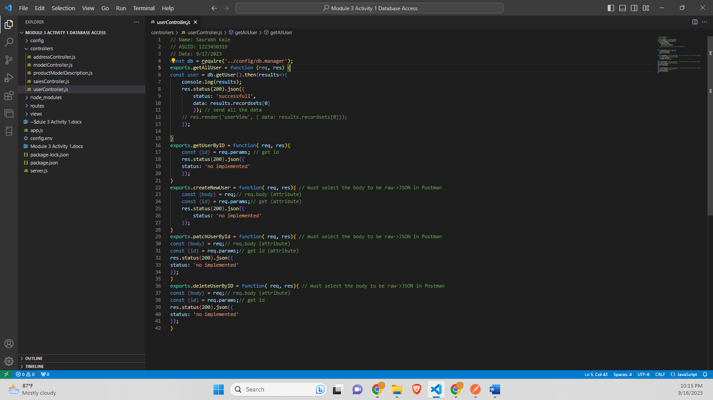

**addressRoutes.js-**

// Name: Saurabh Kale

// ASUID: 1223450319

// Date: 9/17/2023

const express = require('express');

const router = express.Router();

const addressController = require('../controllers/addressController');

router

.route('/')

.get(addressController.getAllAddresses)

.post(addressController.createNewAddress);

router

.route('/:id')

.get(addressController.getAddressByID)

.patch(addressController.patchAddressById)

.delete(addressController.deleteAddressByID);

module.exports = router;

**Screenshot-**

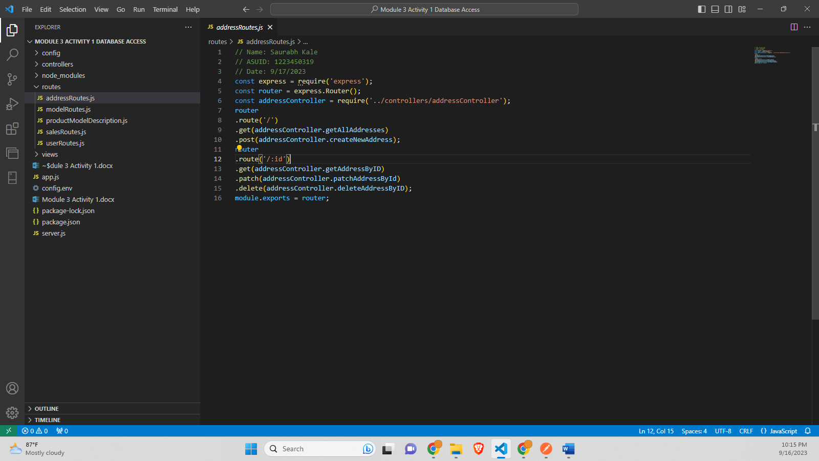

**modelRoutes.js-**

// Name: Saurabh Kale

// ASUID: 1223450319

// Date: 9/17/2023

const express = require('express');

const router = express.Router();

const modelController = require('../controllers/modelController');

router

.route('/')

.get(modelController.getAllModels)

.post(modelController.createNewModel);

router

.route('/:id')

.get(modelController.getModelByID)

.patch(modelController.patchModelById)

.delete(modelController.deleteModelByID);

module.exports = router;

**Screenshot-**

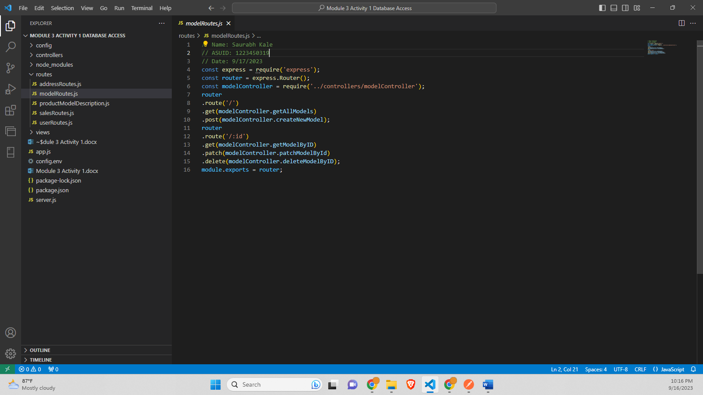

**productModelDescription.js-**

// Name: Saurabh Kale

// ASUID: 1223450319

// Date: 9/17/2023

const express = require('express');

const router = express.Router();

const productModelDescriptionController = require('../controllers/productModelDescription');

router

.route('/')

.get(productModelDescriptionController.getAllProductModelAndDescription)

.post(productModelDescriptionController.createNewProductModelAndDescription);

router

.route('/:id')

.get(productModelDescriptionController.getProductModelAndDescriptionByID)

.patch(productModelDescriptionController.patchProductModelAndDescriptionById)

.delete(productModelDescriptionController.deleteProductModelAndDescriptionByID);

module.exports = router;

**Screenshot-**

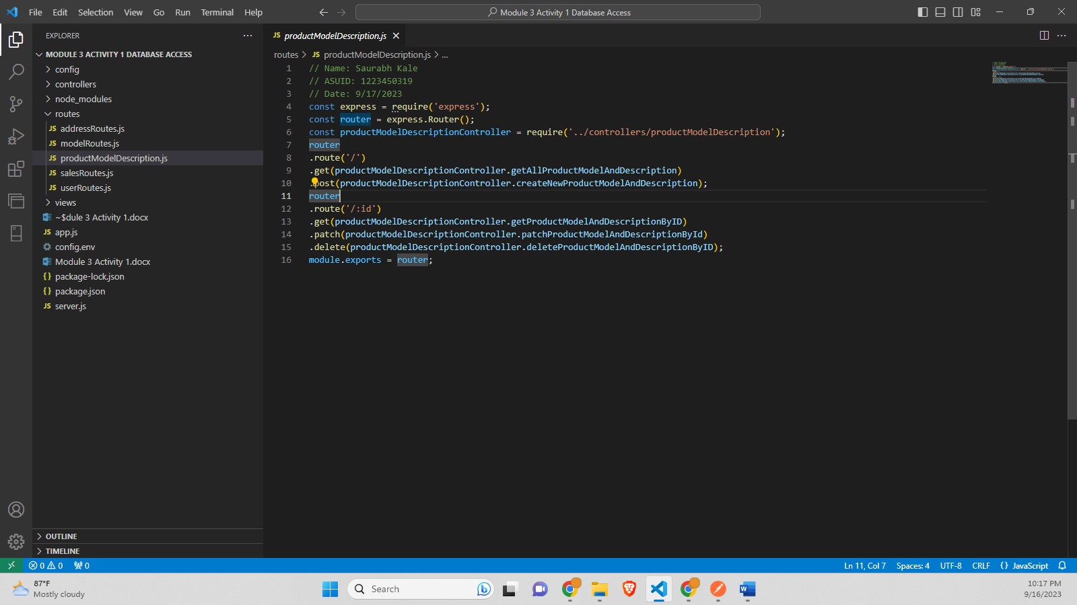

**SalesRoutes.js-**

// Name: Saurabh Kale

// ASUID: 1223450319

// Date: 9/17/2023

const express = require('express');

const router = express.Router();

const salesController = require('../controllers/salesController');

router

.route('/')

.get(salesController.getAllSales)

.post(salesController.createNewSales);

router

.route('/:id')

.get(salesController.getSalesByID)

.patch(salesController.patchSalesById)

.delete(salesController.deleteSalesByID);

module.exports = router;

**Screenshot-**

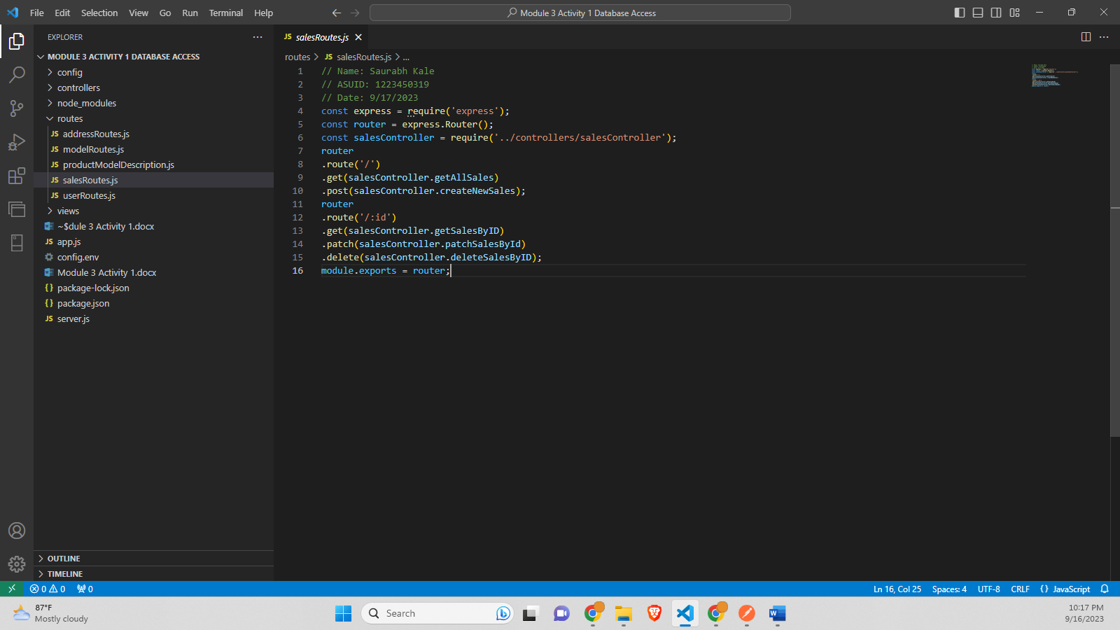

**userRoutes.js-**

// Name: Saurabh Kale

// ASUID: 1223450319

// Date: 9/17/2023

const express = require('express');

const router = express.Router();

const userController = require('../controllers/userController');

router

.route('/')

.get(userController.getAllUser)

.post(userController.createNewUser);

router

.route('/:id')

.get(userController.getUserByID)

.patch(userController.patchUserById)

.delete(userController.deleteUserByID);

module.exports = router;

**Screenshot-**

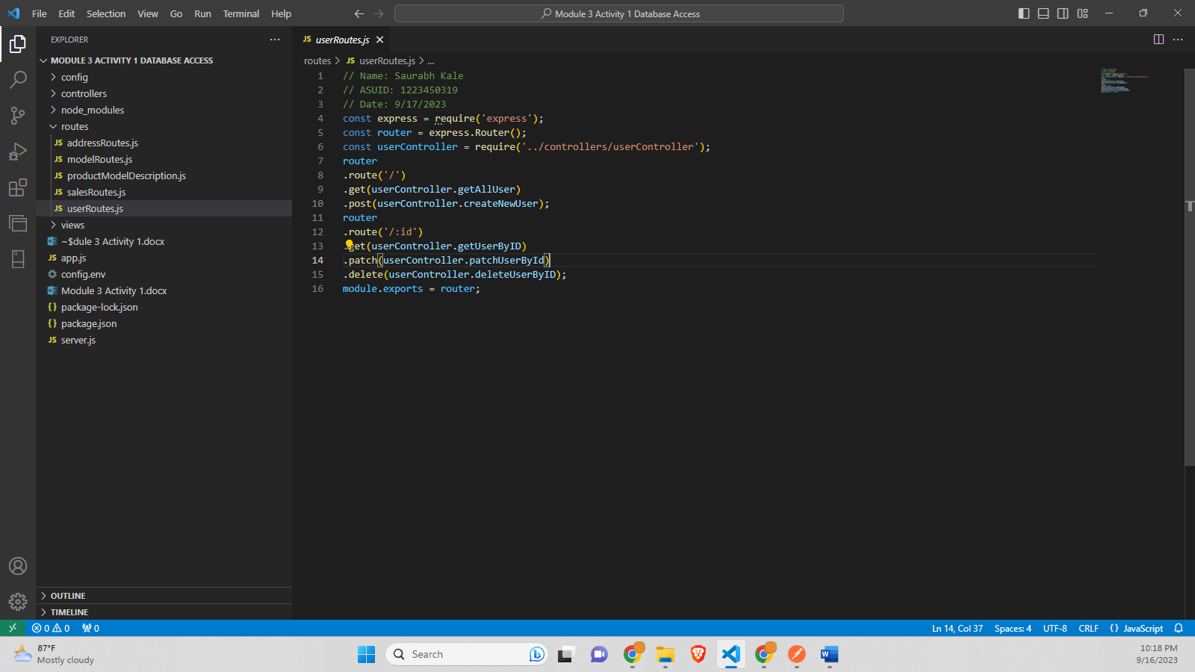

**addressView.js-**

<!--

    Name: Saurabh Kale

    ASU ID: 1223450319

    Datae: 9/12/2023

 -->

 <!DOCTYPE html>

 <html lang="en">

 <head>

     <meta charset="UTF-8">

     <title>Addresss List</title>

     <link rel="stylesheet" href="/styles.css"> <!-- Add a CSS file for styling -->

 </head>

 <body>

     <h1>Addresss List</h1>

     <table>

         <thead>

             <tr>

                 <th>AddressLine1</th>

                 <th>City</th>

                 <th>State Province</th>

                 <th>Country Region</th>

                 <th>PostalCode</th>

                 </tr>

         </thead>

         <tbody>

             <% data.forEach(address => { %>

                 <tr>

                     <td><%= address.AddressLine1 %></td>

                     <td><%= address.City %></td>

                     <td><%= address.StateProvince %></td>

                     <td><%= address.CountryRegion %></td>

                     <td><%= address.PostalCode %></td>

                 </tr>

             <% }); %>

         </tbody>

     </table>

 </body>

 </html>

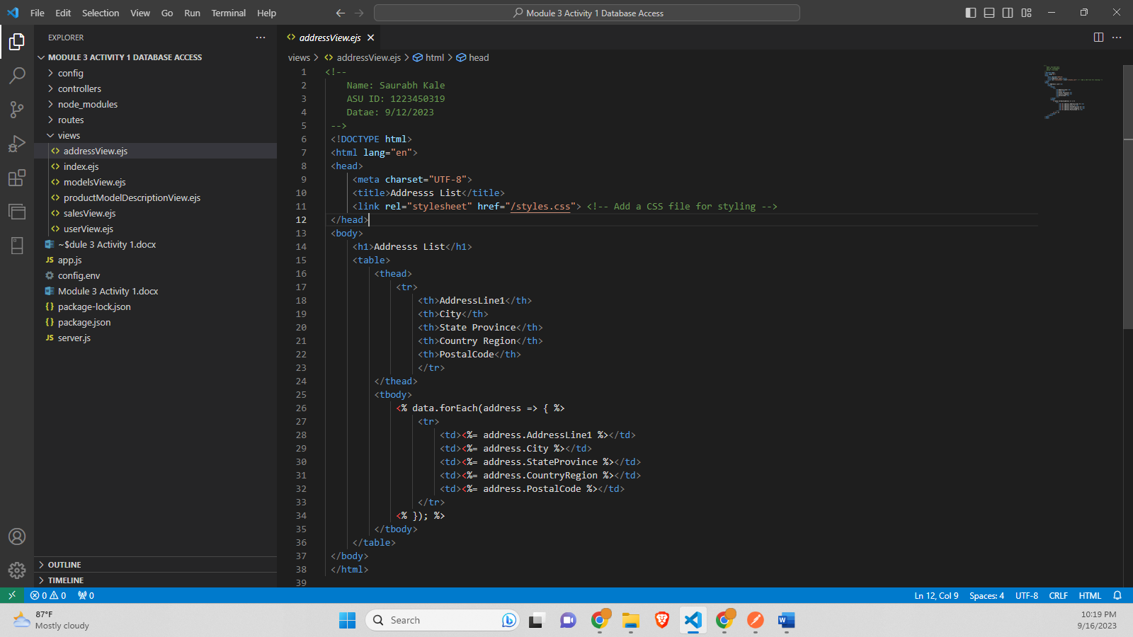

**Index.ejs-**

<!--

    Name: Saurabh Kale

    ASU ID: 1223450319

    Datae: 9/12/2023

 -->

 <!DOCTYPE html>

 <html lang="en">

 <head>

     <meta charset="UTF-8">

     <meta name="viewport" content="width=device-width, initial-scale=1.0">

     <title>Landing Page</title>

     <style>

         /* Basic styling */

         body {

             font-family: Arial, sans-serif;

         }

         header {

             background-color: #333;

             color: white;

             text-align: center;

             padding: 1em 0;

         }

         nav {

             display: flex;

             justify-content: center;

             background-color: #f4f4f4;

             padding: 0.5em 0;

         }

         nav a {

             color: #333;

             padding: 0 15px;

             text-decoration: none;

             transition: background-color 0.3s;

         }

         nav a:hover {

             background-color: #ddd;

         }

         .content {

             max-width: 800px;

             margin: 20px auto;

             padding: 20px;

             background-color: #fff;

             box-shadow: 0 0 10px rgba(0, 0, 0, 0.1);

         }

     </style>

 </head>

 <body>

     <!-- Header section -->

     <header>

         <h1>Welcome to Our Website</h1>

     </header>

     <!-- Navigation menu -->

     <nav>

         <a href="#">Home</a>

         <a href="/api/v1/users">Users</a>

         <a href="/api/v1/sales">Sales</a>

         <a href="/api/v1/models">Models</a>

         <a href="/api/v1/address">Address</a>

         <a href="/api/v1/productModelDescription">Product with Model and Description</a>

     </nav>

     <!-- Content section -->

     <div class="content">

         <h2>Home</h2>

         <p>Welcome to our landing page. Here you can find information about our products and services.</p>

     </div>

 </body>

 </html>

**Screenshot-**

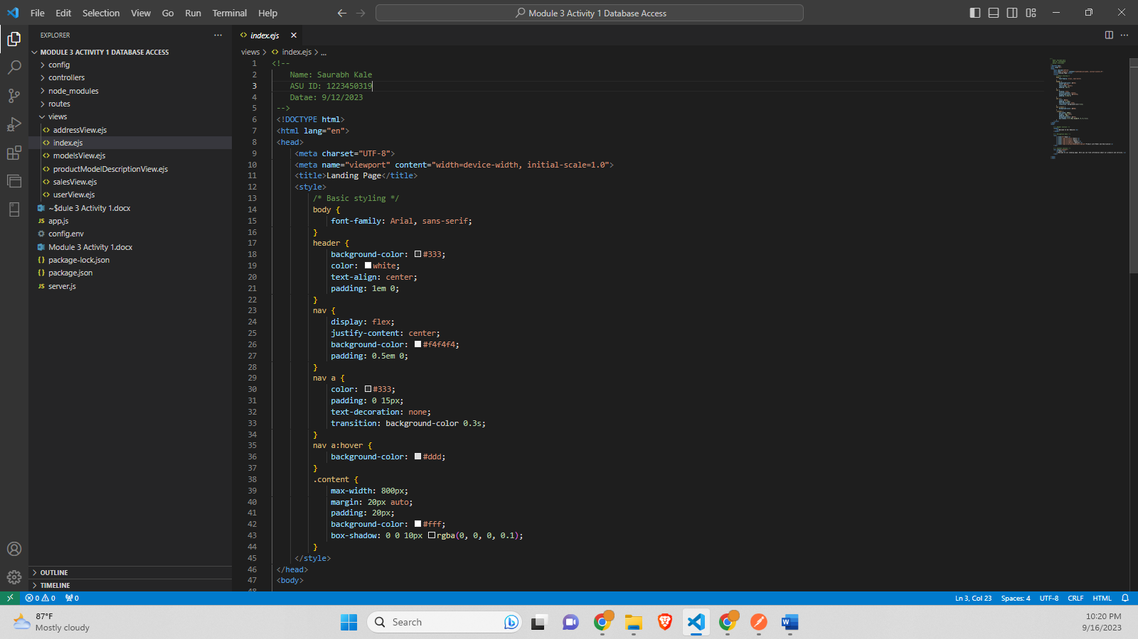

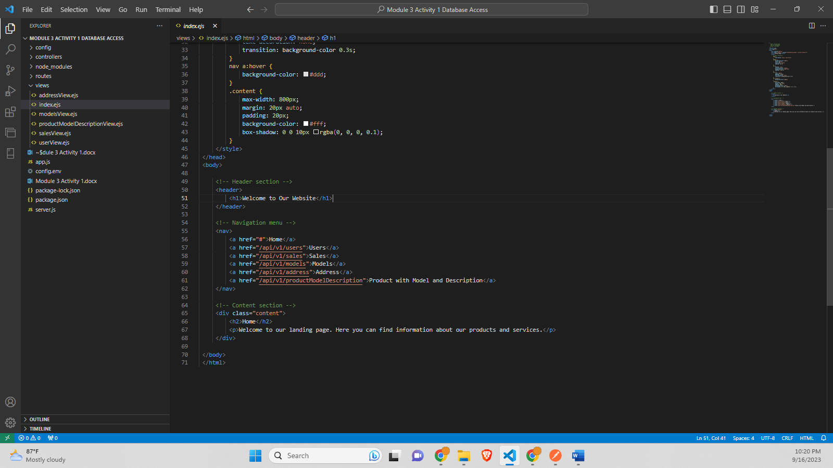

**modelsView.ejs-**

<!--

    Name: Saurabh Kale

    ASU ID: 1223450319

    Datae: 9/12/2023

 -->

 <!DOCTYPE html>

 <html lang="en">

 <head>

     <meta charset="UTF-8">

     <title>Models List</title>

     <link rel="stylesheet" href="/styles.css"> <!-- Add a CSS file for styling -->

 </head>

 <body>

     <h1>Models List</h1>

     <table>

         <thead>

             <tr>

                 <th>Name</th>

                 <!-- <th>Catalog Description</th> -->

                 <th>Row guid</th>

                 <th>Modified Date</th>

                 </tr>

         </thead>

         <tbody>

             <% data.forEach(model => { %>

                 <tr>

                     <td><%= model.Name %></td>

                     <!-- <td><%= model.CatalogDescription %></td> -->

                     <td><%= model.rowguid %></td>

                     <td><%= model.ModifiedDate %></td>

                 </tr>

             <% }); %>

         </tbody>

     </table>

 </body>

 </html>

**Screenshot-**

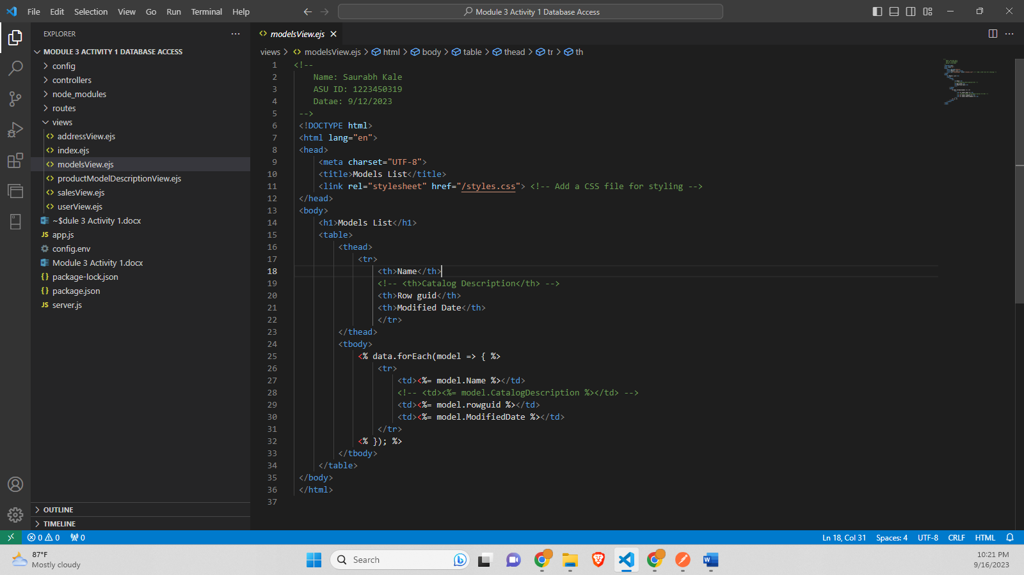

**productModelDescriptionView.ejs-**

<!--

    Name: Saurabh Kale

    ASU ID: 1223450319

    Datae: 9/12/2023

 -->

 <!DOCTYPE html>

 <html lang="en">

 <head>

     <meta charset="UTF-8">

     <title>Product MD List</title>

     <link rel="stylesheet" href="/styles.css"> <!-- Add a CSS file for styling -->

 </head>

 <body>

     <h1>Product Model and Description Join List</h1>

     <table>

         <thead>

             <tr>

                 <th>ProductID</th>

                 <th>Name</th>

                 <th>ProductModelID</th>

                 <th>ProductCategoryID</th>

                 <th>Culture</th>

                 </tr>

         </thead>

         <tbody>

             <% data.forEach(productMC => { %>

                 <tr>

                    <td><%= productMC.ProductID %></td>

                    <td><%= productMC.Name %></td>

                    <td><%= productMC.ProductModelID %></td>

                    <td><%= productMC.ProductCategoryID %></td>

                    <td><%= productMC.Culture %></td>

                 </tr>

             <% }); %>

         </tbody>

     </table>

 </body>

 </html>

**Screenshot-**

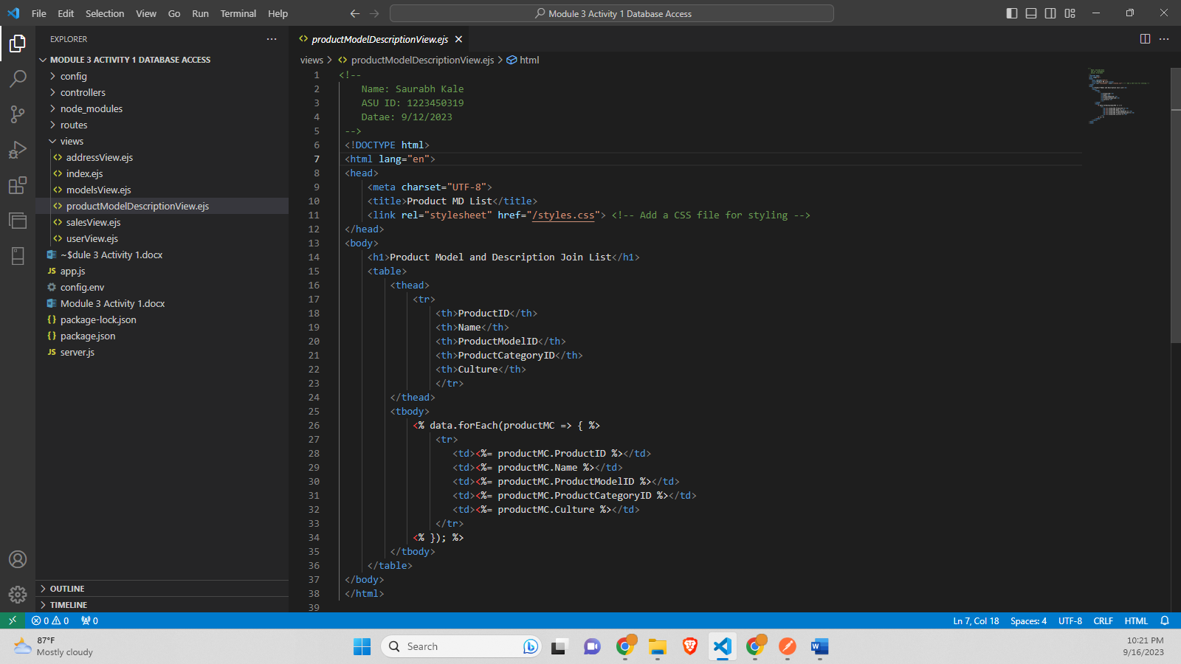

**salesView.ejs-**

<!--

    Name: Saurabh Kale

    ASU ID: 1223450319

    Datae: 9/12/2023

 -->

 <!DOCTYPE html>

 <html lang="en">

 <head>

     <meta charset="UTF-8">

     <title>Sales List</title>

     <link rel="stylesheet" href="/styles.css"> <!-- Add a CSS file for styling -->

 </head>

 <body>

     <h1>Sales List</h1>

     <table>

         <thead>

             <tr>

                 <th>Product ID</th>

                 <th>Name</th>

                 <th>Product Number</th>

                 <th>List Price</th>

                 </tr>

         </thead>

         <tbody>

             <% data.forEach(sale => { %>

                 <tr>

                     <td><%= sale.productId %></td>

                     <td><%= sale.name %></td>

                     <td><%= sale.productNumber %></td>

                     <td><%= sale.listPrice %></td>

                 </tr>

             <% }); %>

         </tbody>

     </table>

 </body>

 </html>

**Screenshot-**

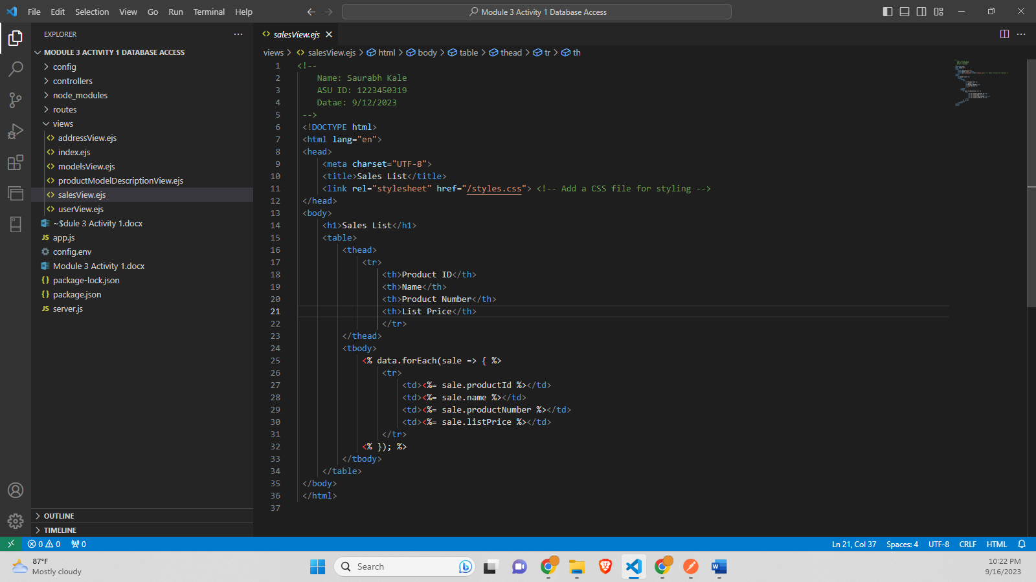

**userView.ejs-**

<!--

    Name: Saurabh Kale

    ASU ID: 1223450319

    Datae: 9/12/2023

 -->

 <!DOCTYPE html>

 <html lang="en">

 <head>

     <meta charset="UTF-8">

     <title>Customer List</title>

     <link rel="stylesheet" href="/styles.css"> <!-- Add a CSS file for styling -->

 </head>

 <body>

     <h1>Customer List</h1>

     <table>

         <thead>

             <tr>

                 <th>Customer ID</th>

                 <th>First Name</th>

                 <th>Last Name</th>

                 <th>Email Address</th>

                 <th>Phone</th>

                 <th>Company Name</th>

             </tr>

         </thead>

         <tbody>

             <% data.forEach(customer => { %>

                 <tr>

                     <td><%= customer.CustomerID %></td>

                     <td><%= customer.FirstName %></td>

                     <td><%= customer.LastName %></td>

                     <td><%= customer.EmailAddress %></td>

                     <td><%= customer.Phone %></td>

                     <td><%= customer.CompanyName %></td>

                 </tr>

             <% }); %>

         </tbody>

     </table>

 </body>

 </html>

**Screenshot-**

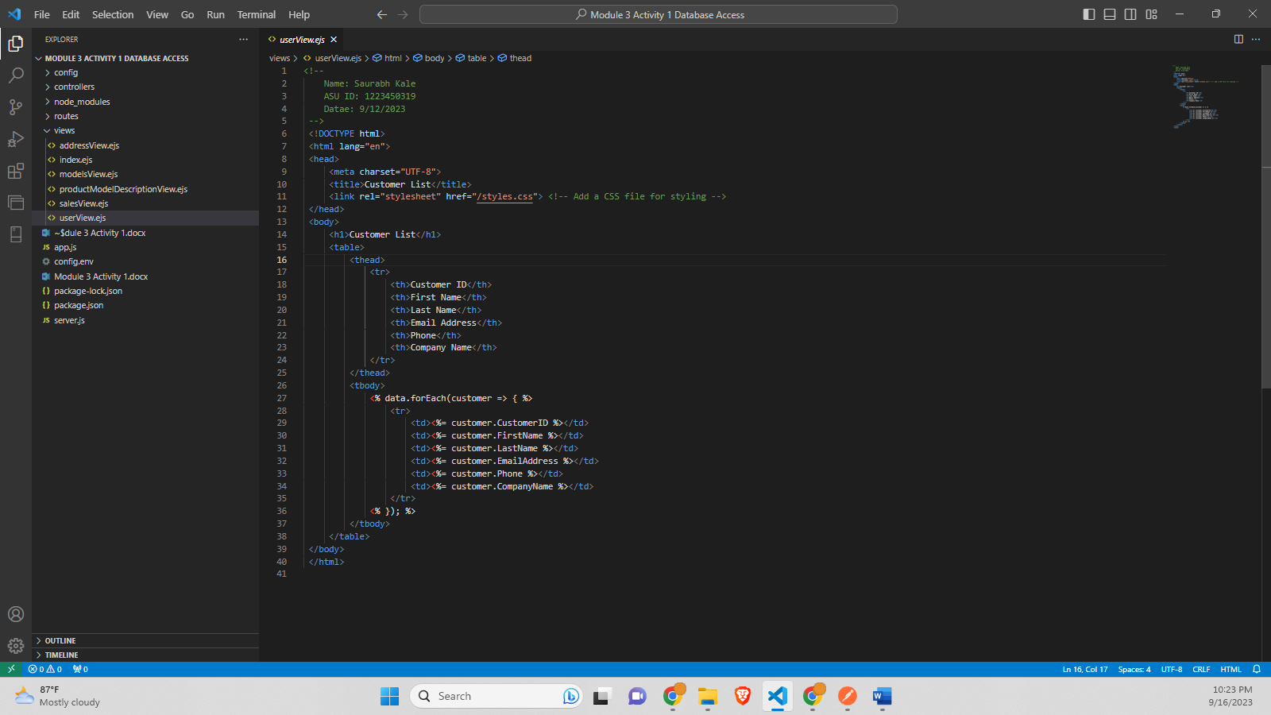

**Postman Result for GET request on address-**

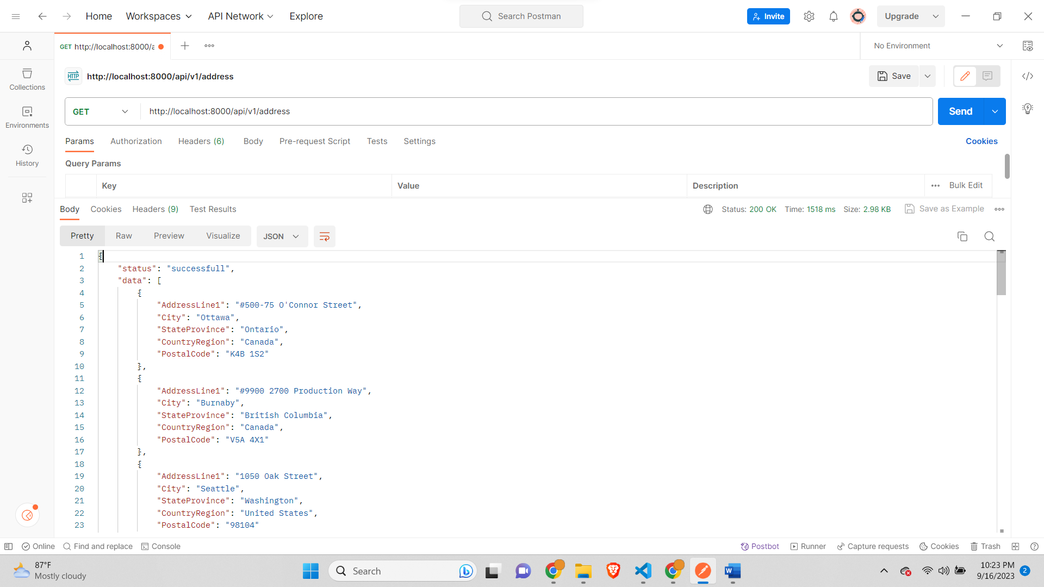

**Postman Result for GET request on models-**

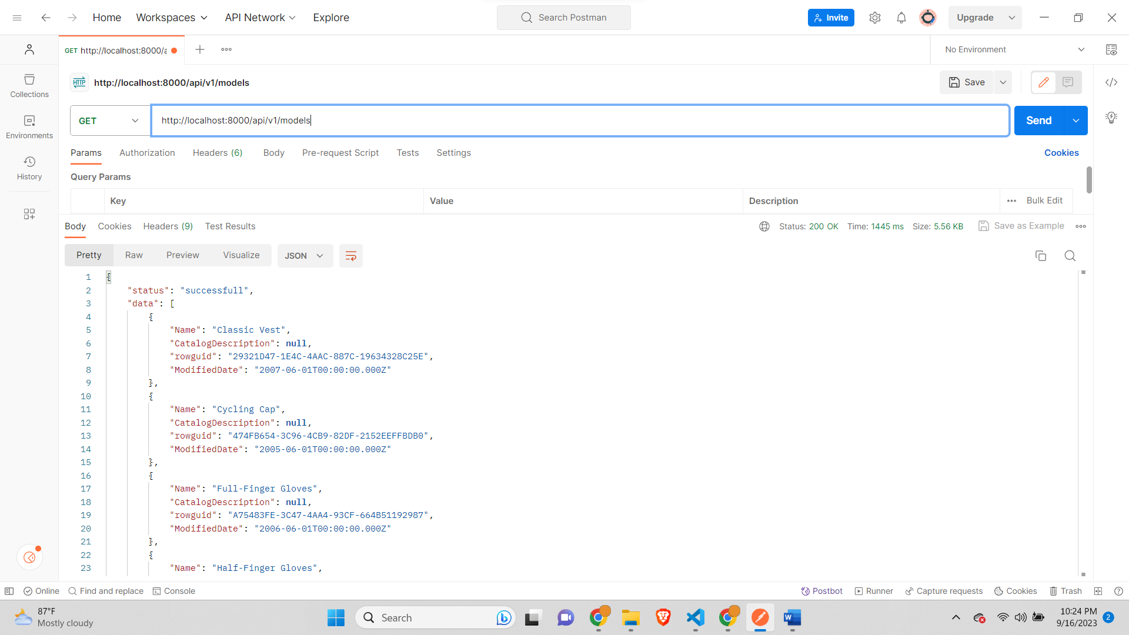

**Postman result for GET Request on sales-**

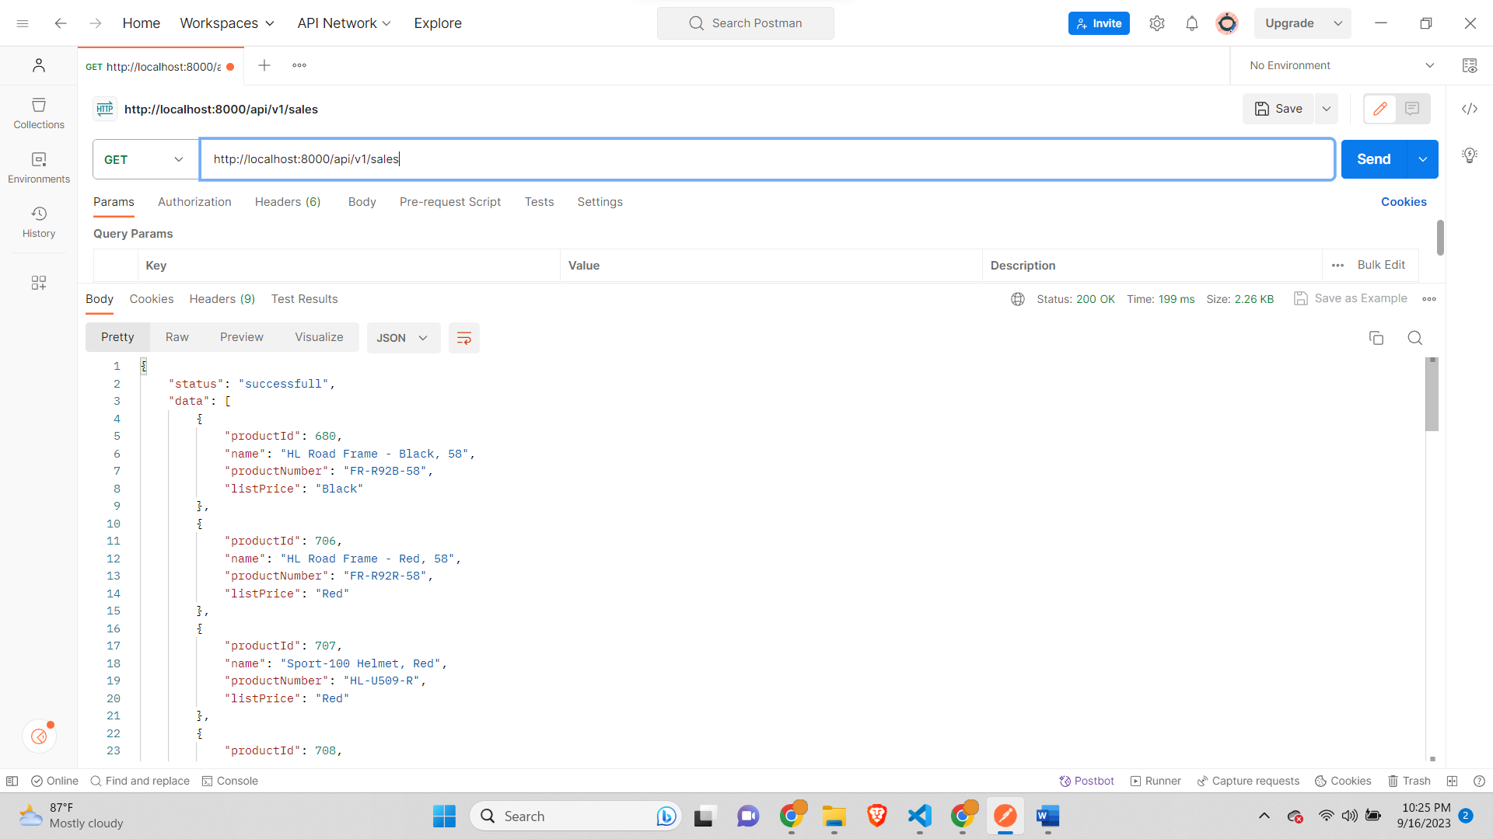

**Postman result for GET Request on users-**

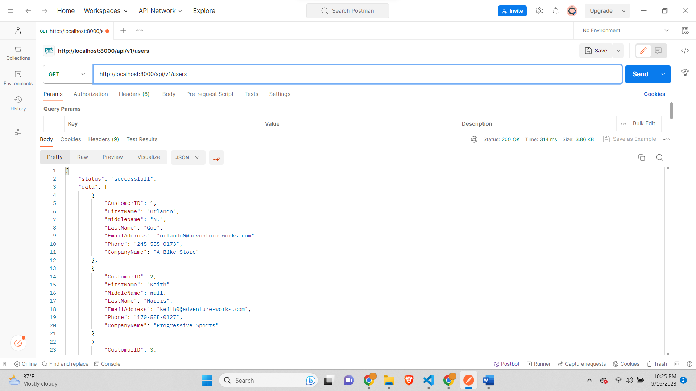

**Postman request for GET request for productModelDescription-**

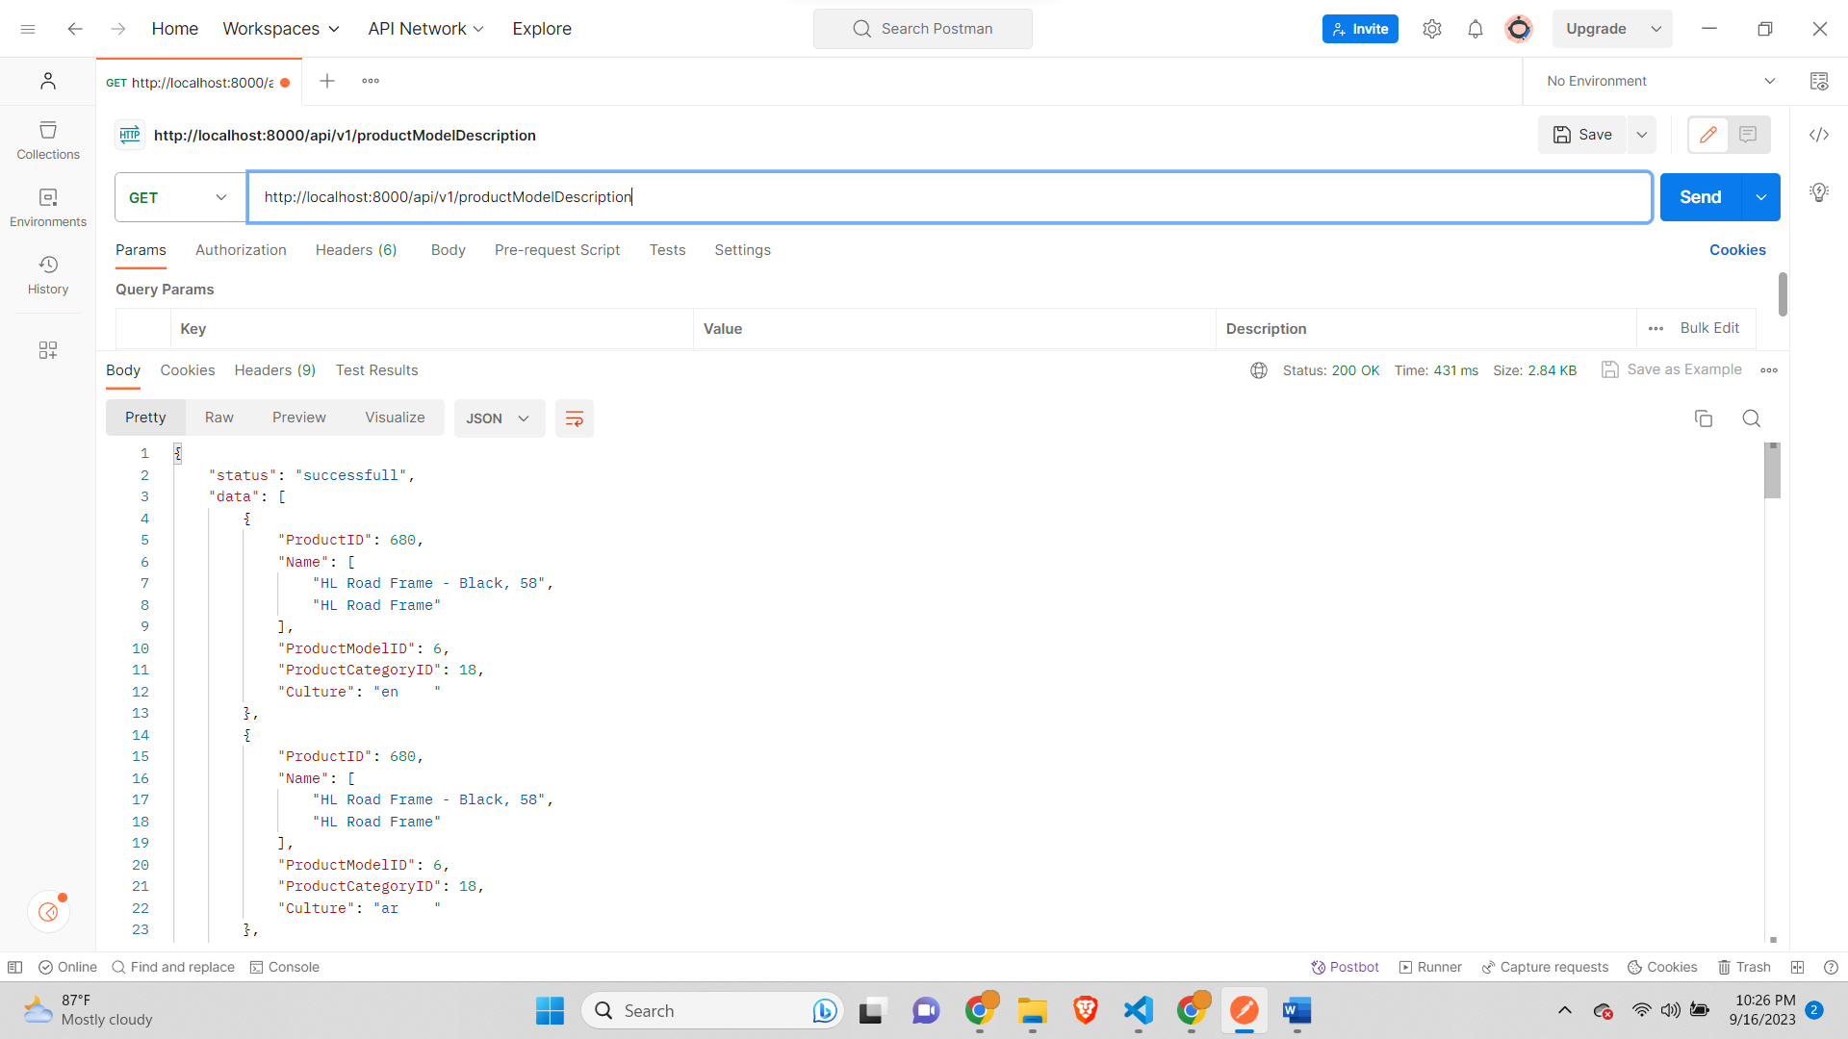

**By adding view to all the controllers the data is visible in tabular form on UI-**

**Home Page-**

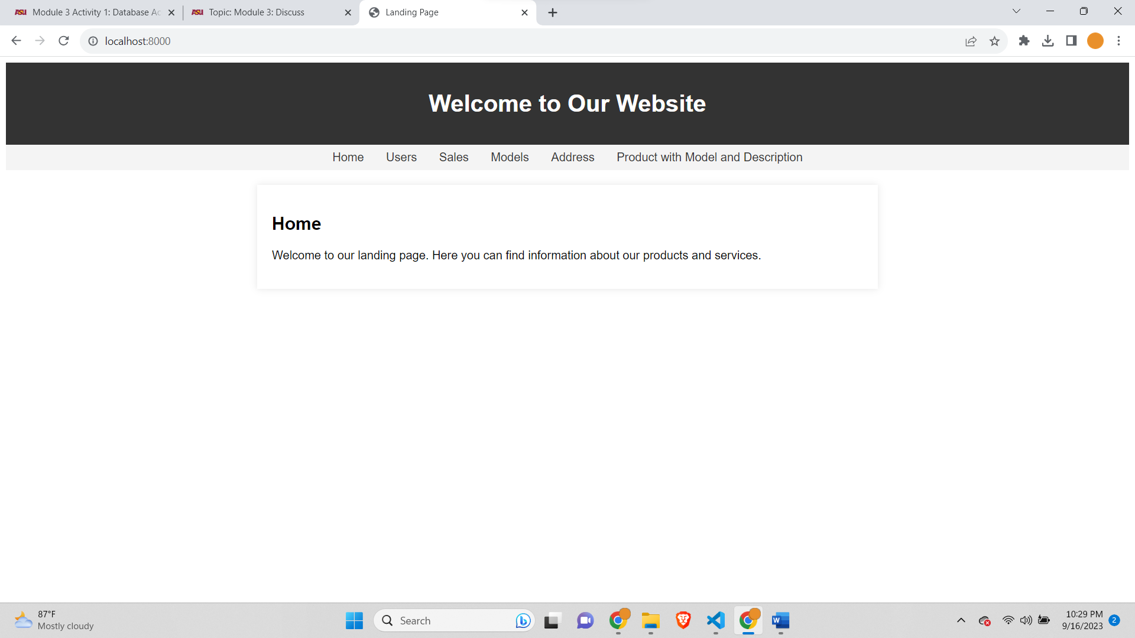

**After clicking on Users the User’s page-**

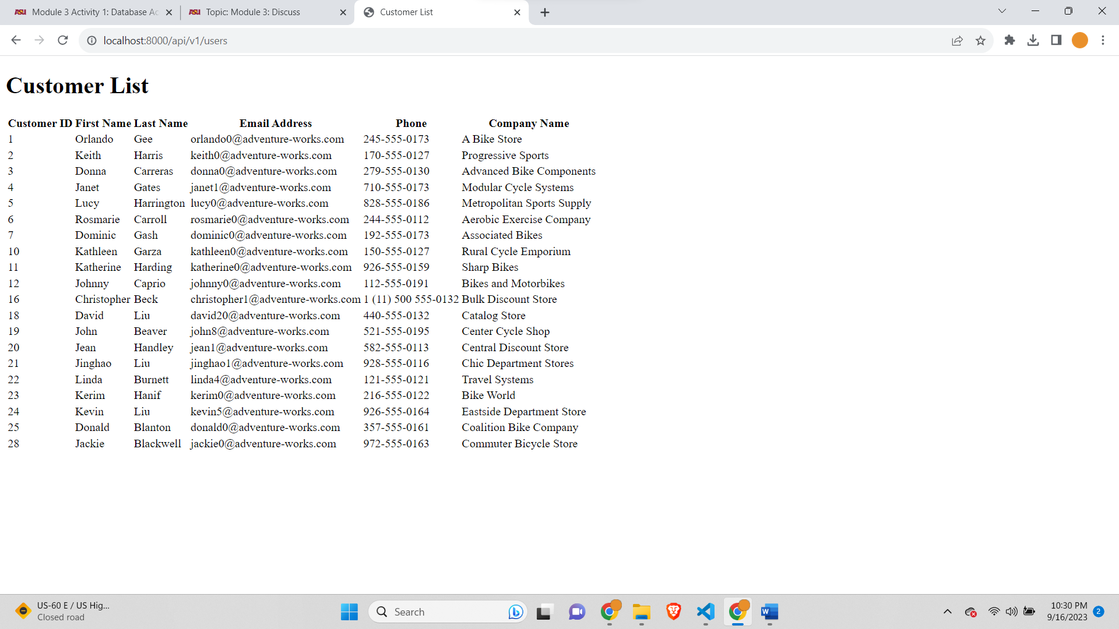

**After clicking on Sales on the home page the Sale’s page-**

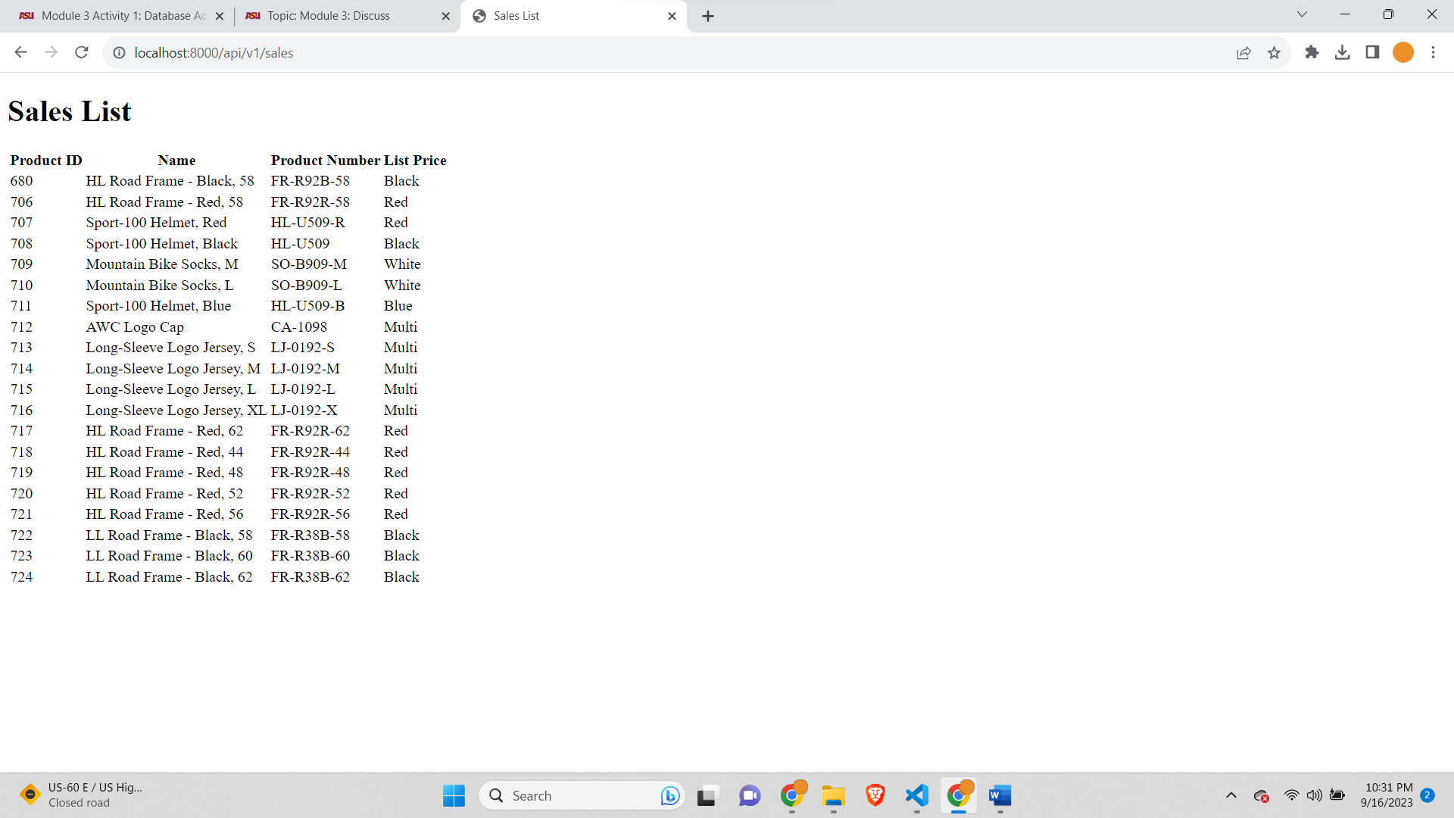

**After clicking on Models on the home page the Model’s page-**

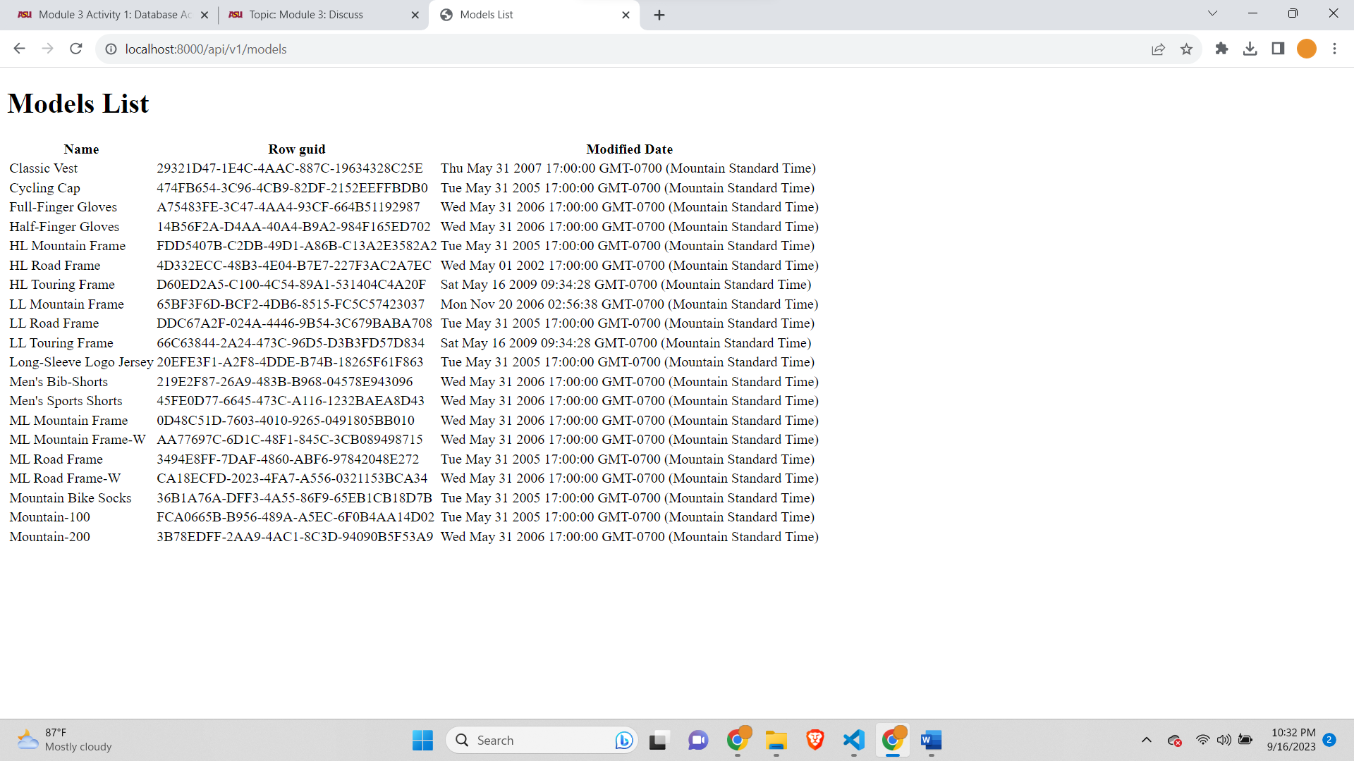

**After clicking on Address on the home page the Address page-**

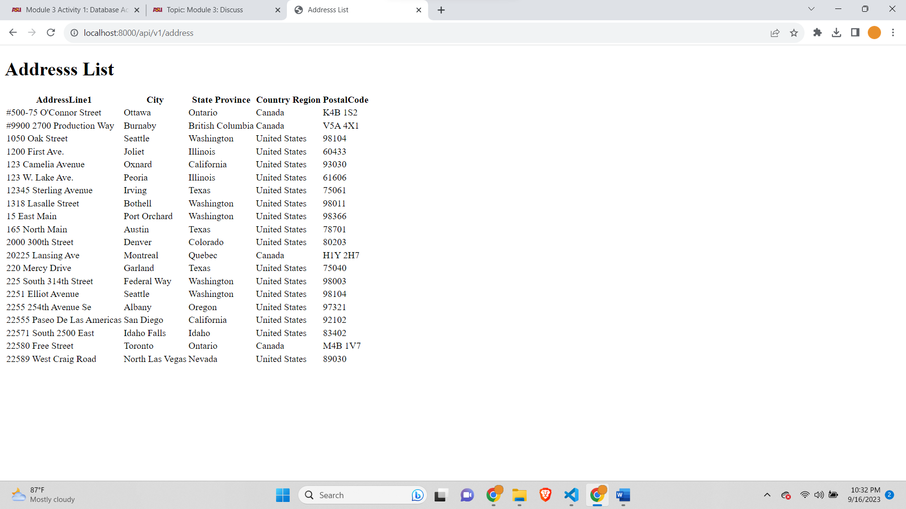

**After clicking on ‘**[**Product with Model and Description**](http://localhost:8000/api/v1/productModelDescription)**’ on home page the ‘Product with Model and Description**’ **which is join of 3 Tables-**

